**Name: Sharavani Krishna Desai**

**Class: T.Y. B.Sc. C.S. Sem-VI**

**Roll. No: 712**

**Subject: Ethical Hacking**

**INDEX**

|  |  |  |  |  |
| --- | --- | --- | --- | --- |
| **Sr. No** | **Date** | **Practical Aim** | **Page No.** | **Remark** |
| 1 | 25/02/2021 | Use Google and whois for Reconnaissance. |  |  |
| 2 | 25/02/2021 | A] Use Cryptool to encrypt and decrypt passwords using RCA Algorithm.  B] Use Cain and Abel for cracking Windows account password using Dictionary attack and to decode wireless network passwords. |  |  |
| 3 | 04/03/2021 | A] Run and analyze the output of the following commands in Linux- ifconfig, ping, netstat, traceroute.  B] Perform ARP Poisoning in Windows. |  |  |
| 4 | 18/03/2021 | Use Nmap scanner to perform port scanning of various forms- ACK, SYN, FIN, NULL, XMAS. |  |  |
| 5 | 25/03/2021 | A] Use Wireshark sniffer to capture network traffic and analyze.  B] Use Nemesy or smd to launch a DOS attack. |  |  |
| 6 | 08/04/2021 | Simulate persistent Cross Site Scripting attack. |  |  |
| 7 | 12/04/2021 | Session impersonation using Firefox and Tamper Data add-on. |  |  |
| 8 | 15/04/2021 | Perform SQL injection attack. |  |  |

**Date:25/02/2021**

**PRACTICAL NO: 1**

**Aim :-** Use Google and Whois for Reconnaissance

**Step-1 :-** Go to https://www.myntra.com/whois-lookup and enter the website name

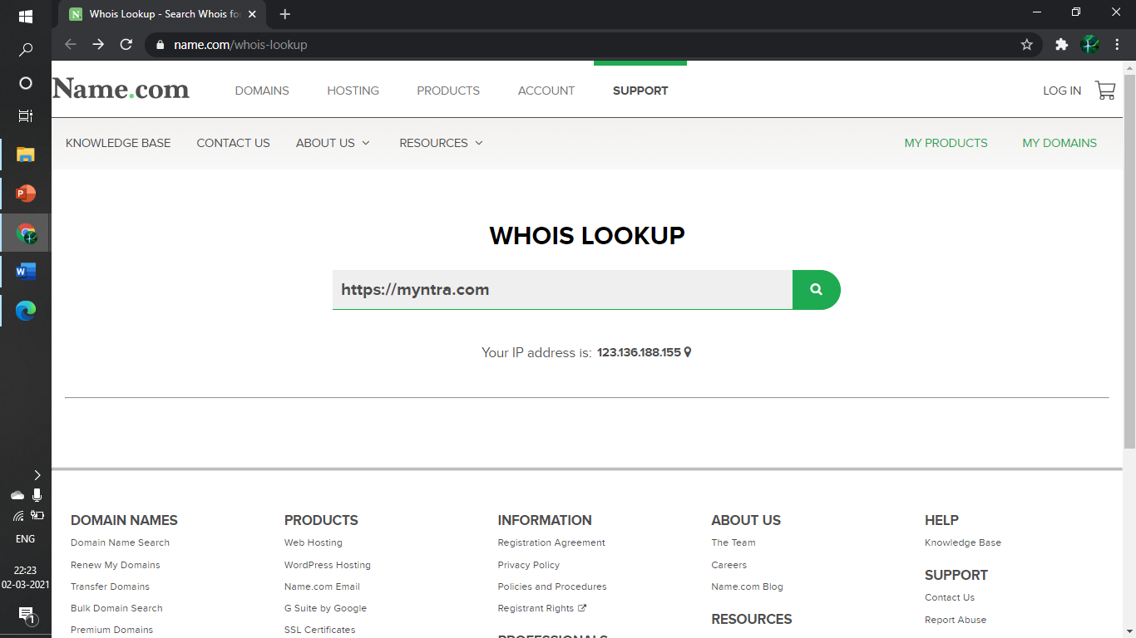

**Step-2 :-** After Captcha Verification it will release all the details about the website like DNS,server, CA provider etc..

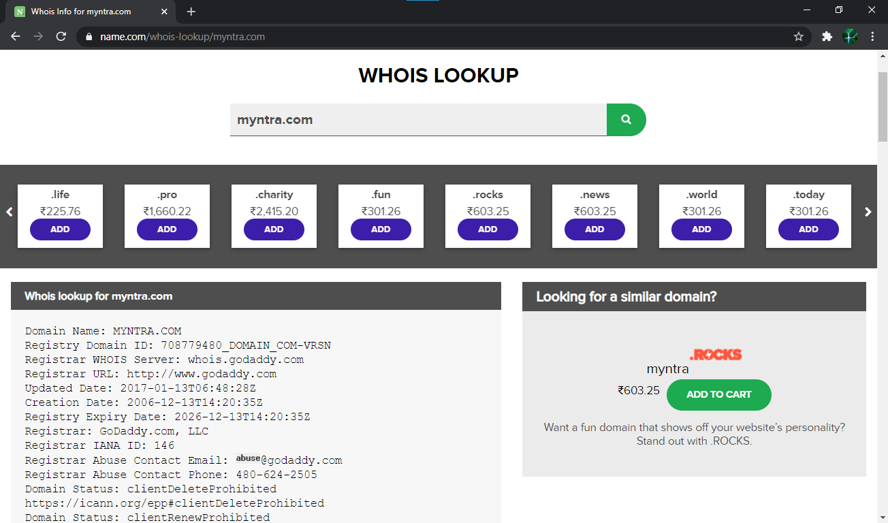

Second Website

**Step-1 :-** Go to https://www.ajiio.com/whois-lookup and enter the website name

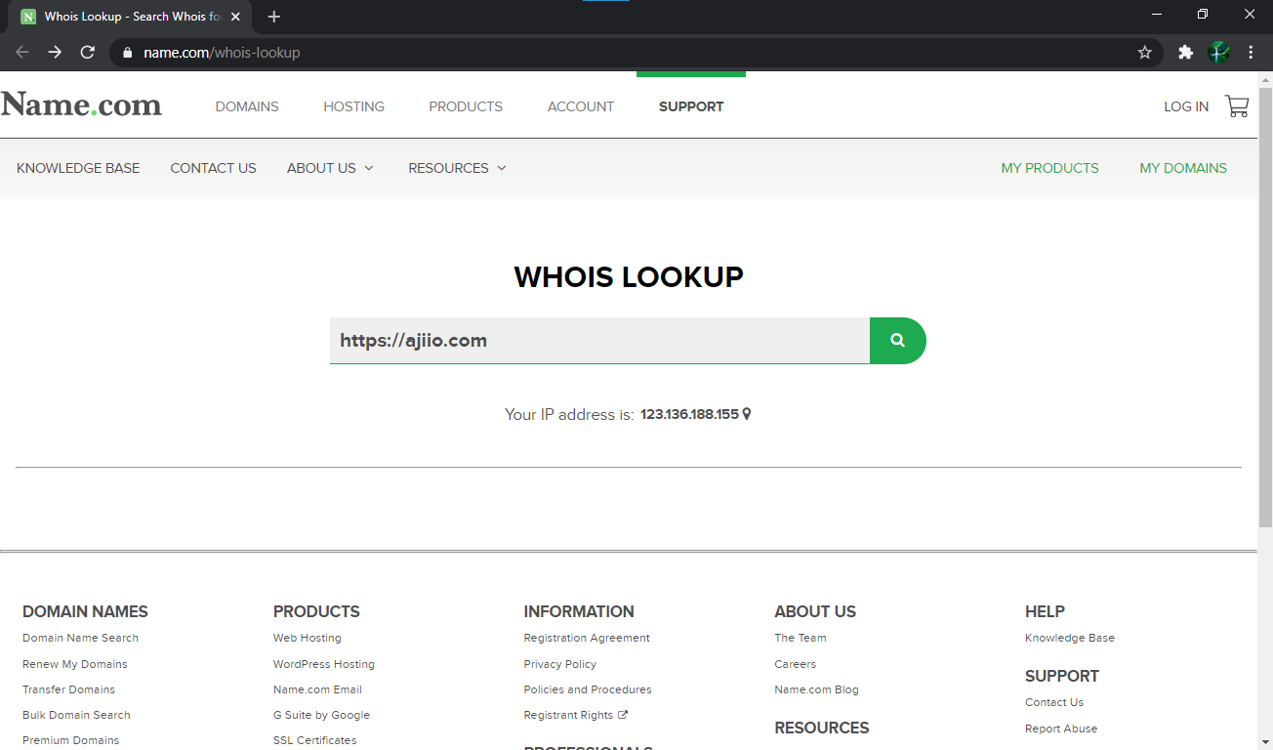

**Step-2 :-** After Captcha Verification it will release all the details about the website like DNS,server, CA provider etc..

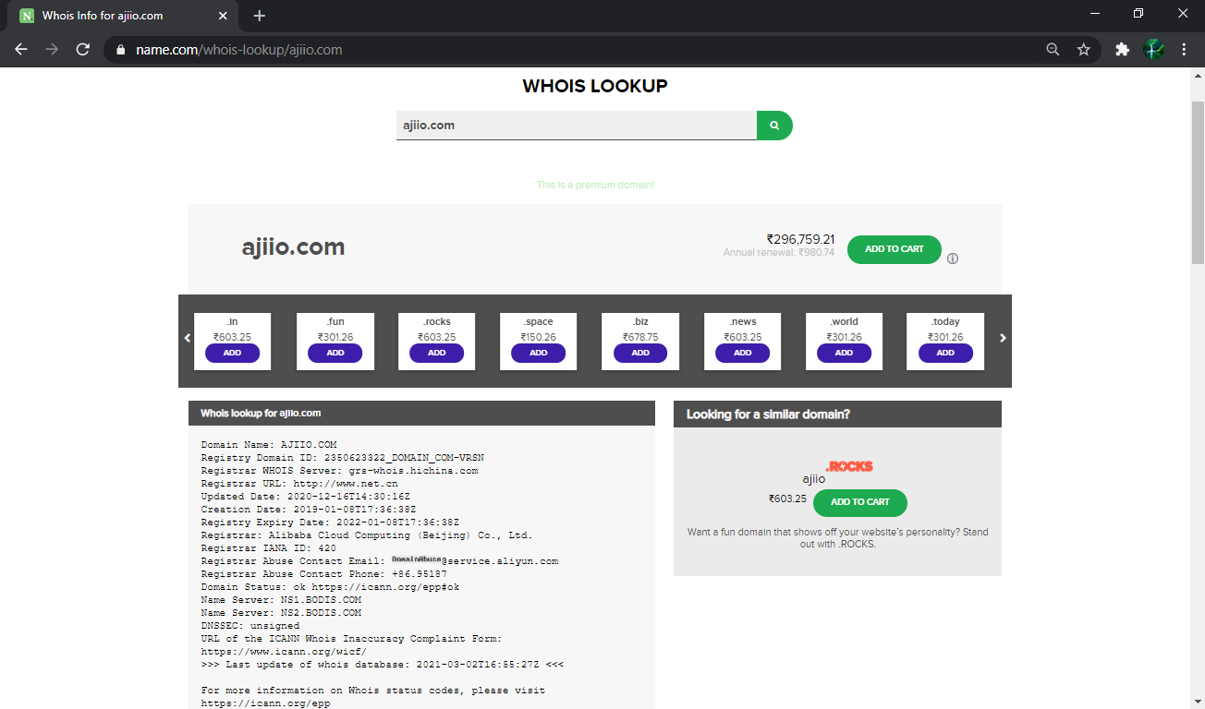

**Date:25/02/2021**

**PRACTICAL NO: 2**

**Aim :-** a) Use CrypTool to encrypt and decrypt passwords using RC4 algorithm b) Use Cain and Abel for cracking Windows account password using Dictionary attack and to decode wireless network passwords

1. Use CrypTool to encrypt and decrypt passwords using RC4 algorithm

**Steps**

Step-1 :- Open CrypTool in a new window and create a new file

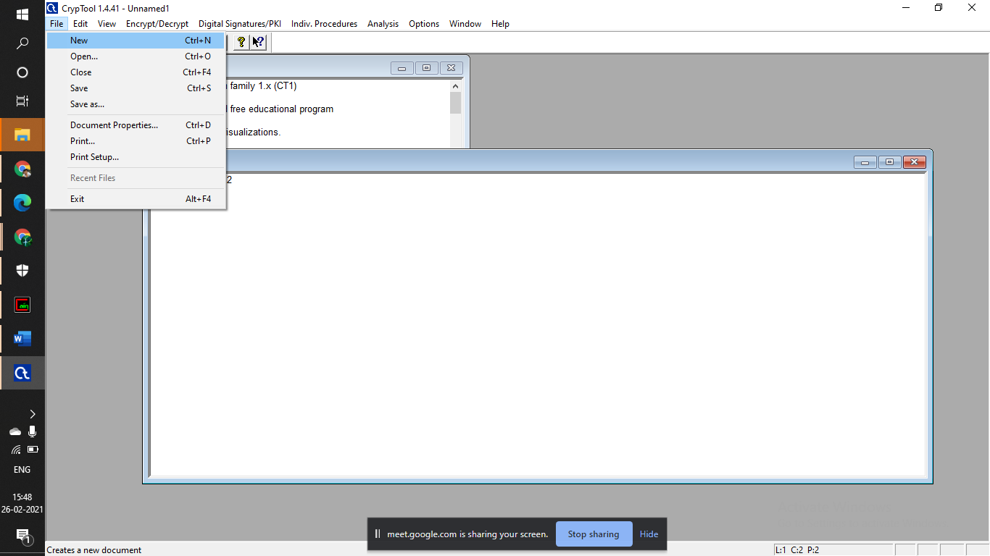

Step-2 :- Type some text into the document for encryption and decryption

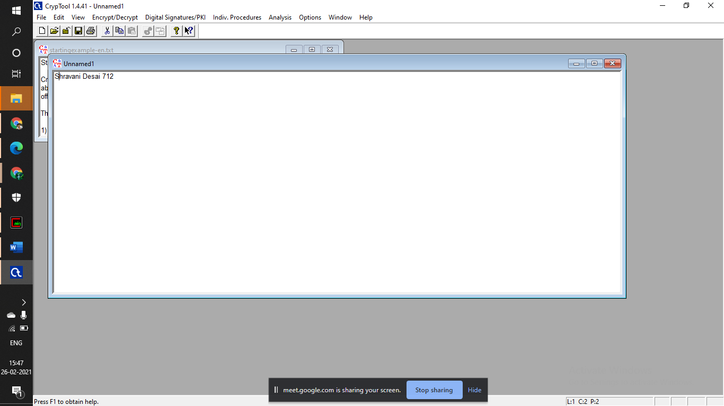

Step-3 :- Save the file in fie explorer as a normal text file.

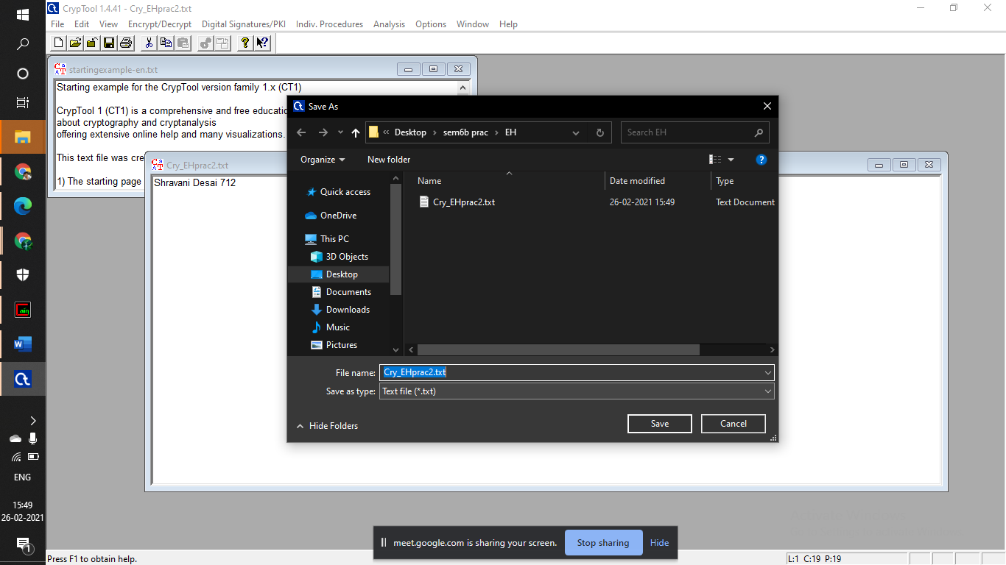

Step 4 :- Next Go into Encrypt/Decrypt tab → select Symmetric(modern) → RC4..

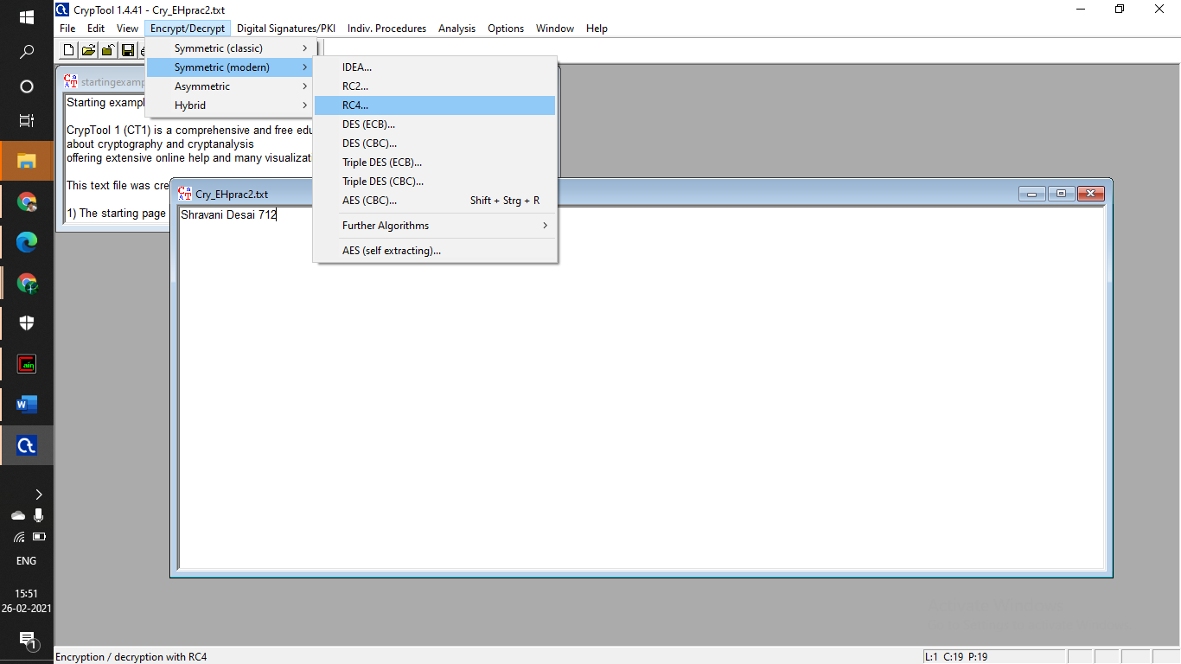

Step-5 :- Next Click on Encrypt

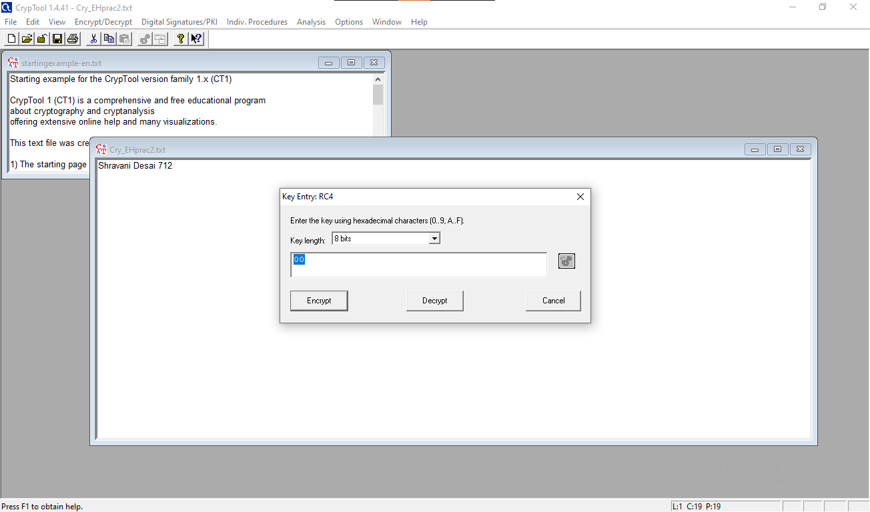

Step-6 :- It will Encrypt the text using RC4 algorithm and show it in a new window

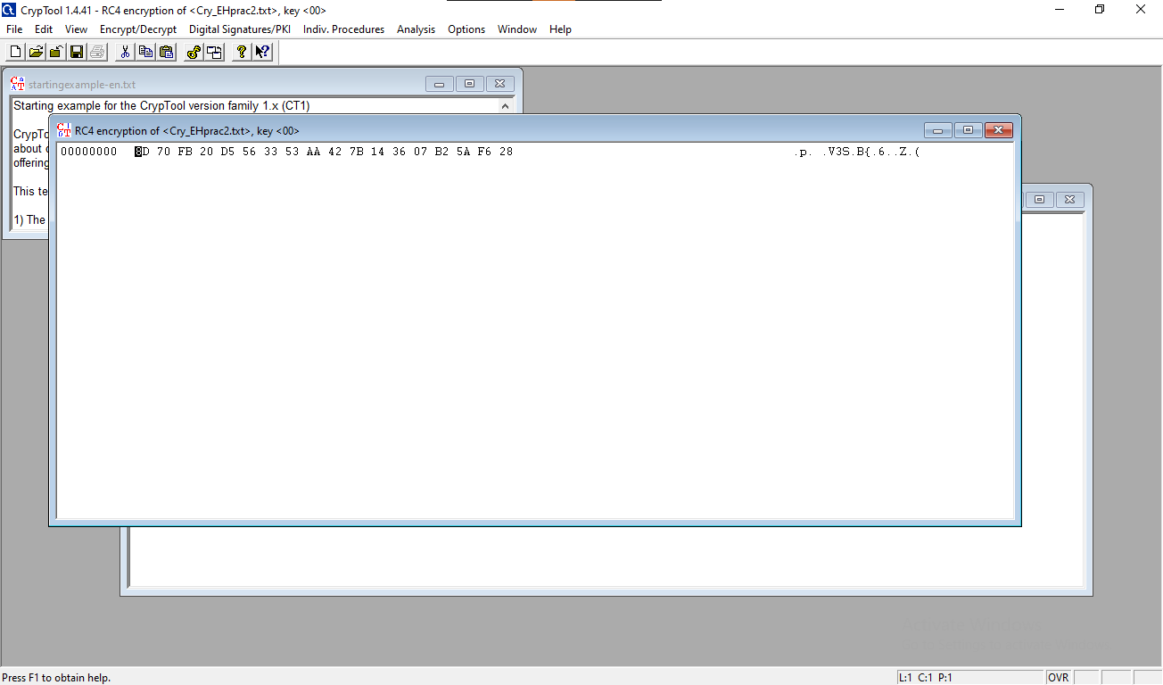

8D 70 FB 20 D5 56 33 53 AA 42 7B 14 36 07 B2 5A F6 28

Step-7 :- Next Go into Encrypt/Decrypt tab → select Symmetric(modern) → RC4.. and click on the Decrypt button.

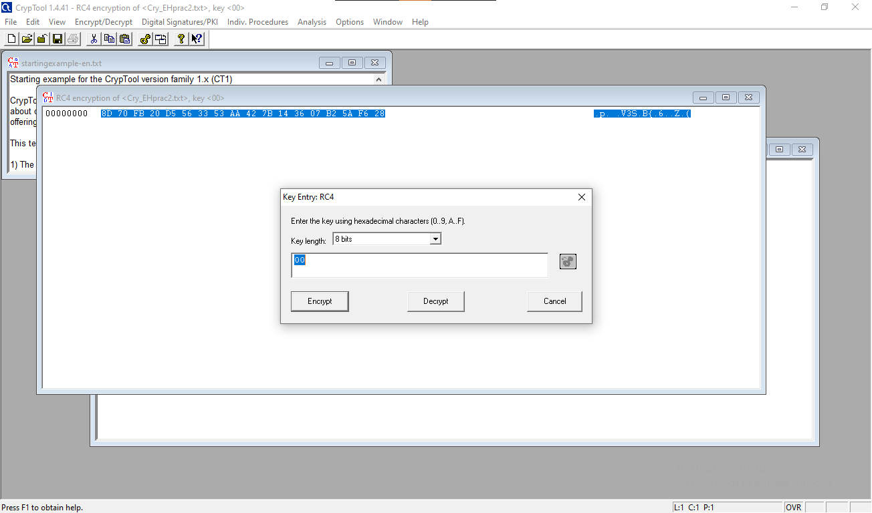

Step-8 :- It will show the decrypted output on a new window.

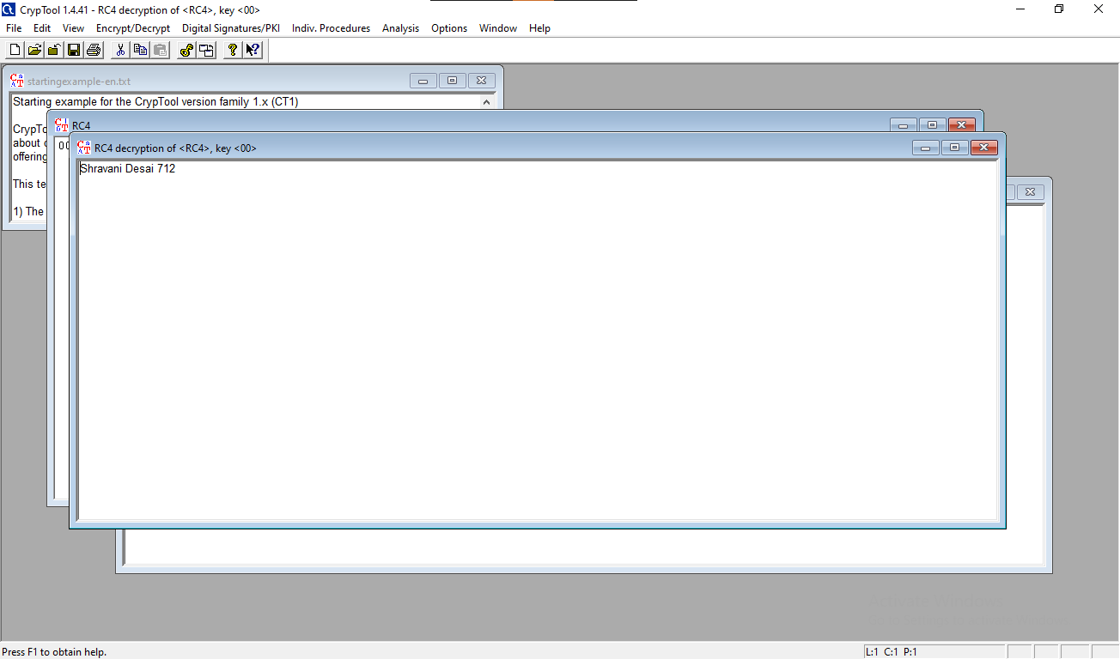

1. Use Cain and Abel for cracking Windows account password using Dictionary attack and to decode wireless network passwords

**Steps**

Step-1 :- Open Cain app and navigate to tools → Hash Calculator.

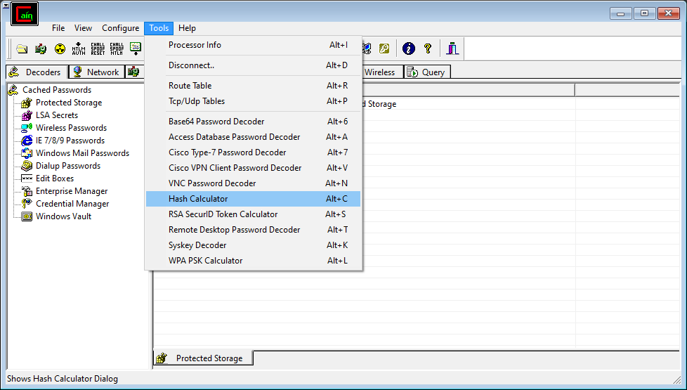

Step-2 :- Enter some text and click on calculate. It will printout all hash codes, copy the one of MD5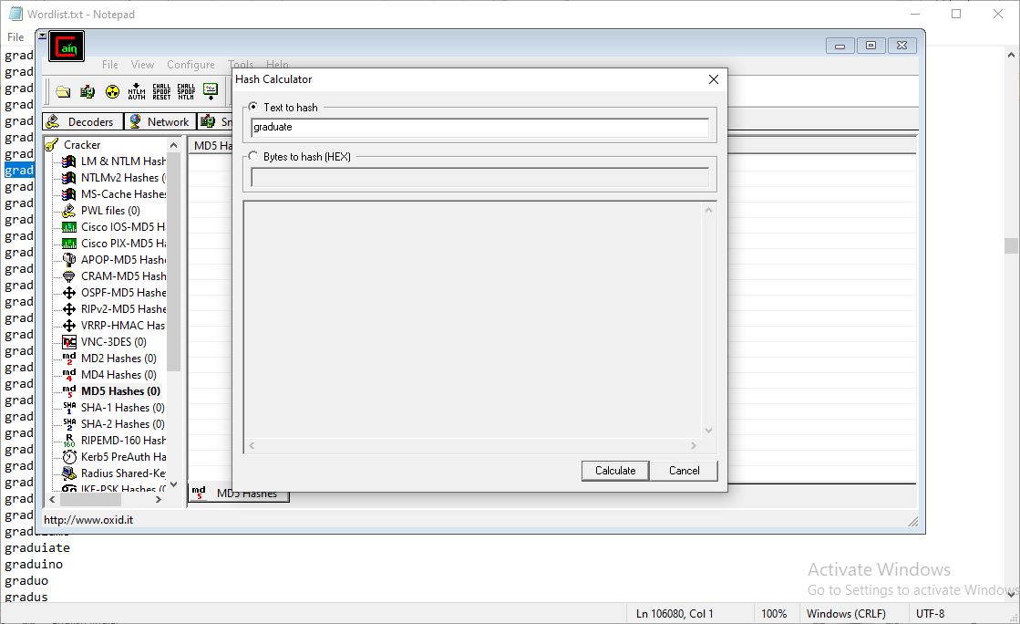

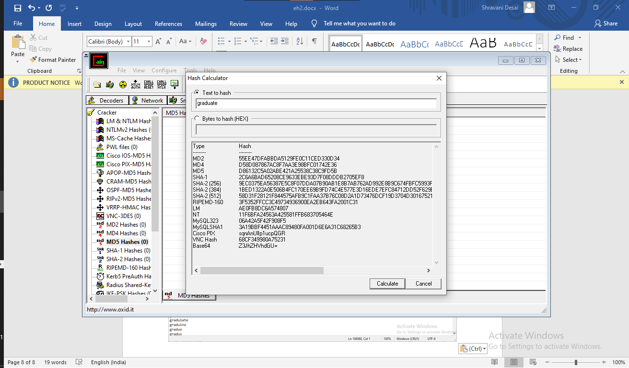

D86132C5A02ABE421A25538C38C9FD5B

Step-3 :- Next navigate to cracker tab and MD5 Hashes section. Next insert an entry and paste the Hex code of Hash value

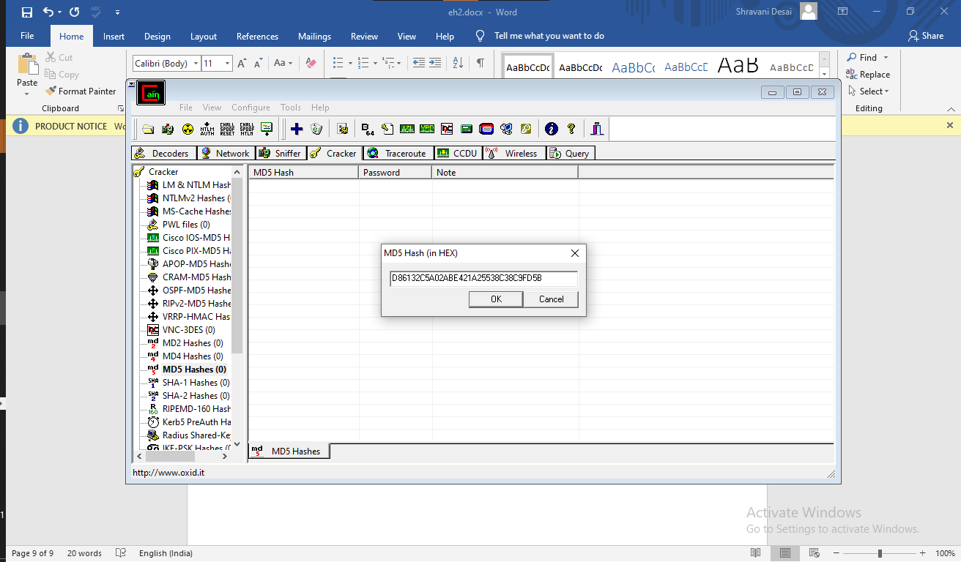

Step-4 :- Next select the entry → right click and Dictionary Attack.

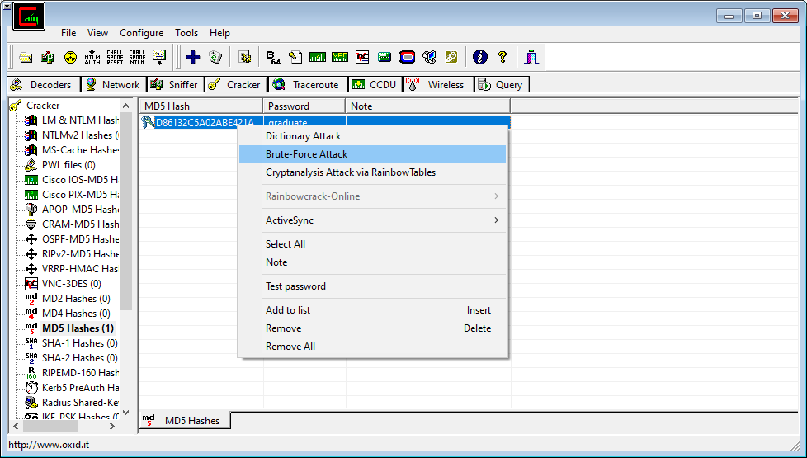

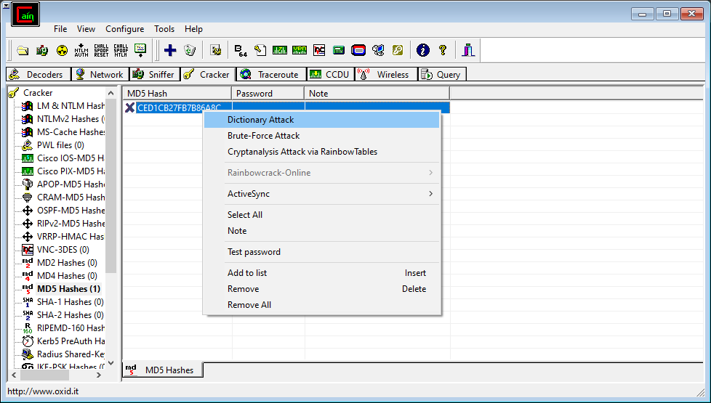

Step-5 :- A window will open and now you need to attach a word list dictionary and open a Wordlist.

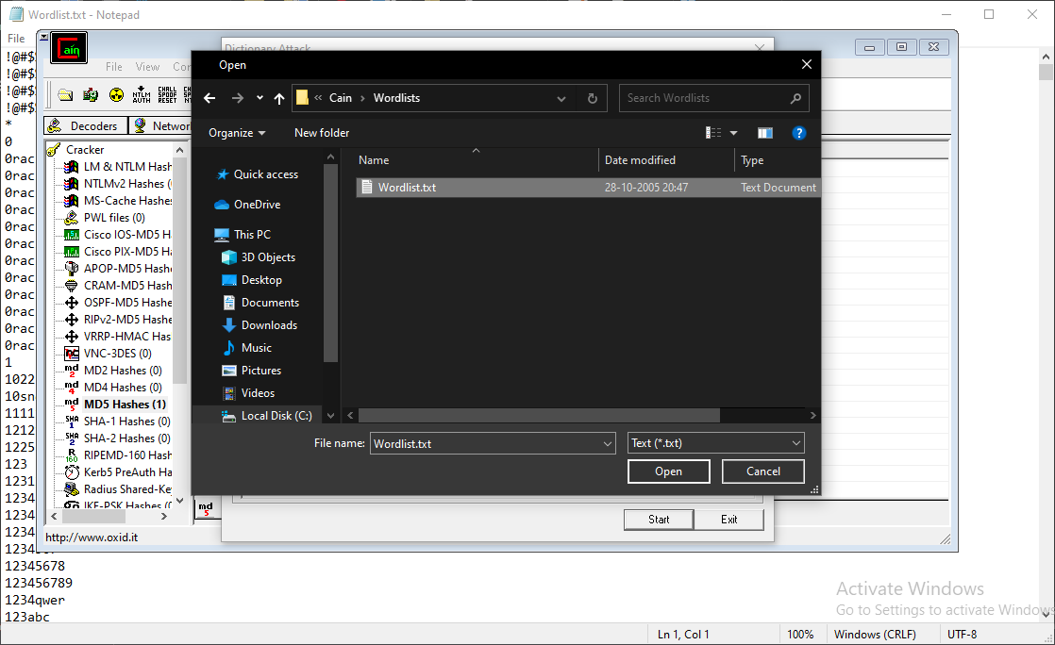

Step-6 :- Next click on Start and it should probably find the plain text in a few minutes

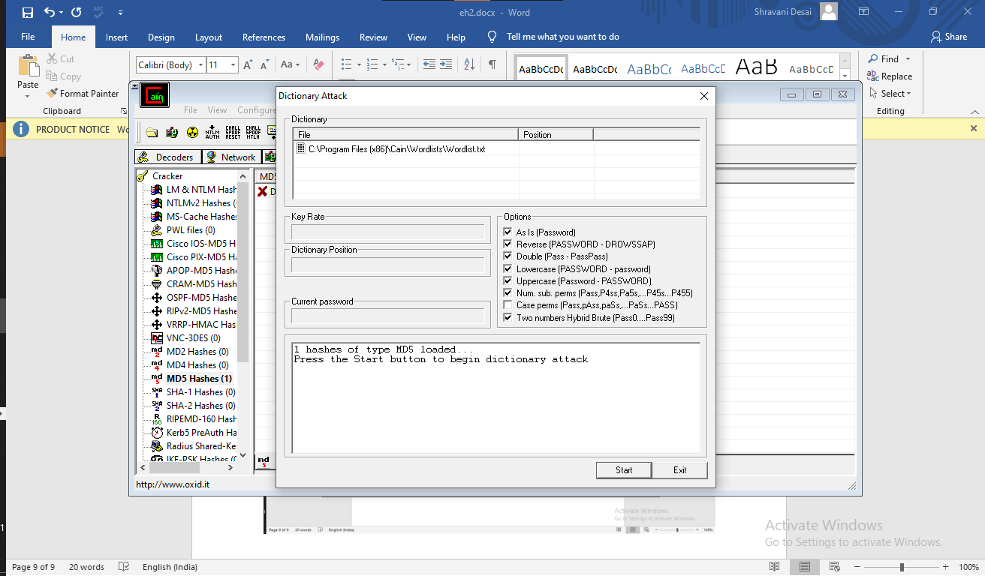

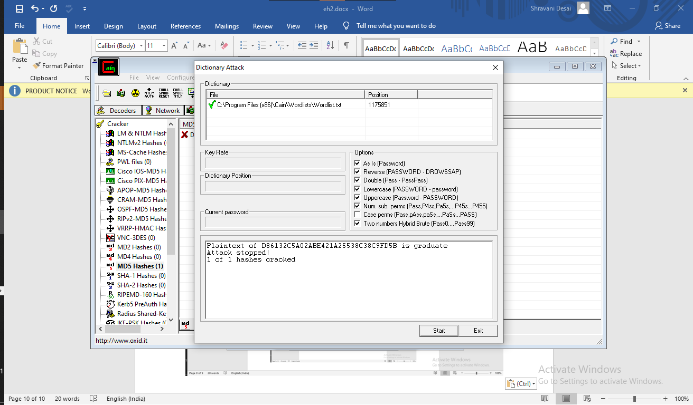

**Brute Force Attack**

Step-7 :- Next open Hash Calculator again and type some text for Brute force attack and click calculate. Copy the MD5 Hash code.



Step-8 :- Add an entry to the same cracker MD5 section. Paste the Hash value and click on OK.

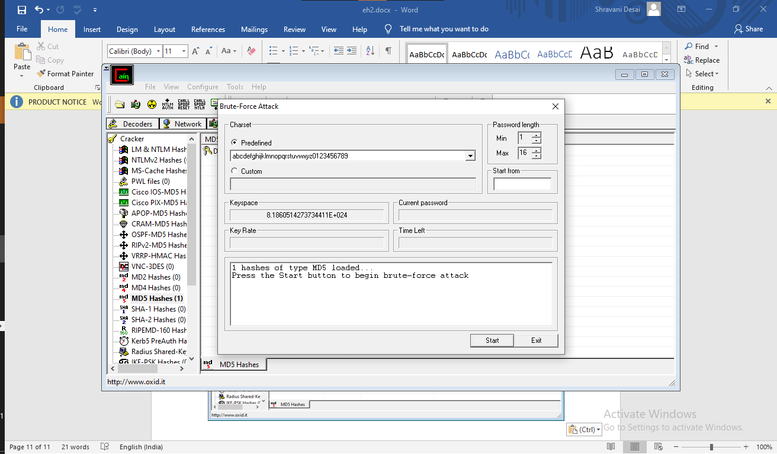

Step-9 :- On the Brute force Window click on start and once it cracks the Hash value it will stop automatically.

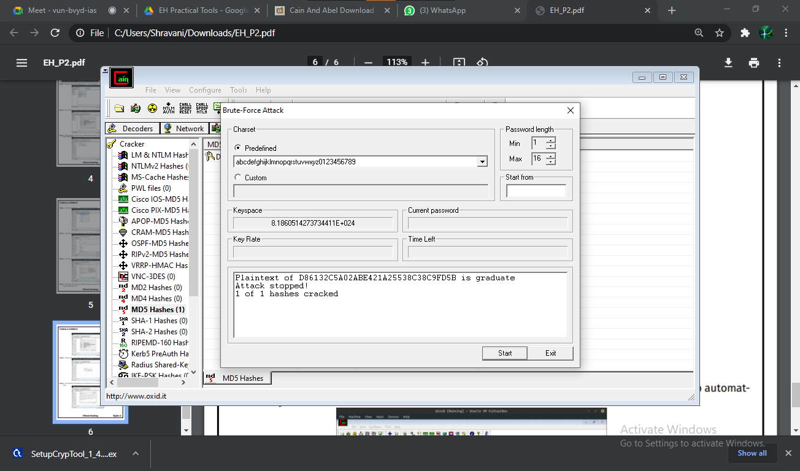

**Date:04/03/2021**

**Practical No: 3**

**AIM: A) Run and analyze the output of following commands in Linux –ifconfig, ping,netstat, traceroute**

**B) Perform ARP Poisoning in Windows**

**A . Run and analyze the output of following commands in Linux –ifconfig, ping,netstat, traceroute**

**Ifconfig**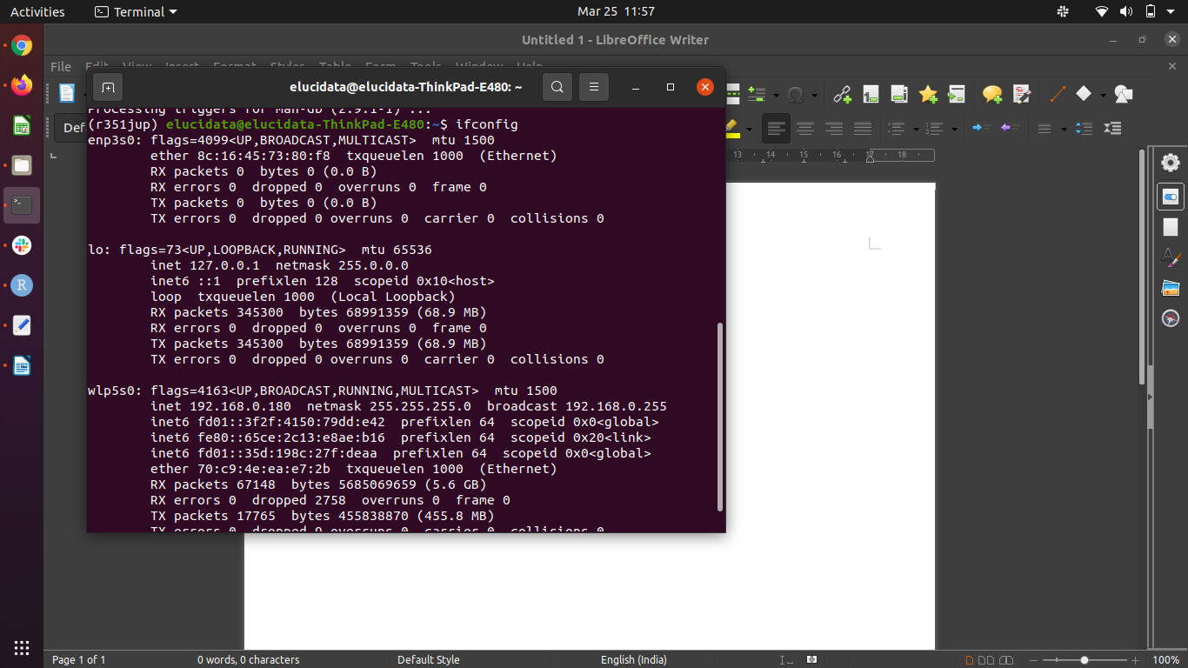

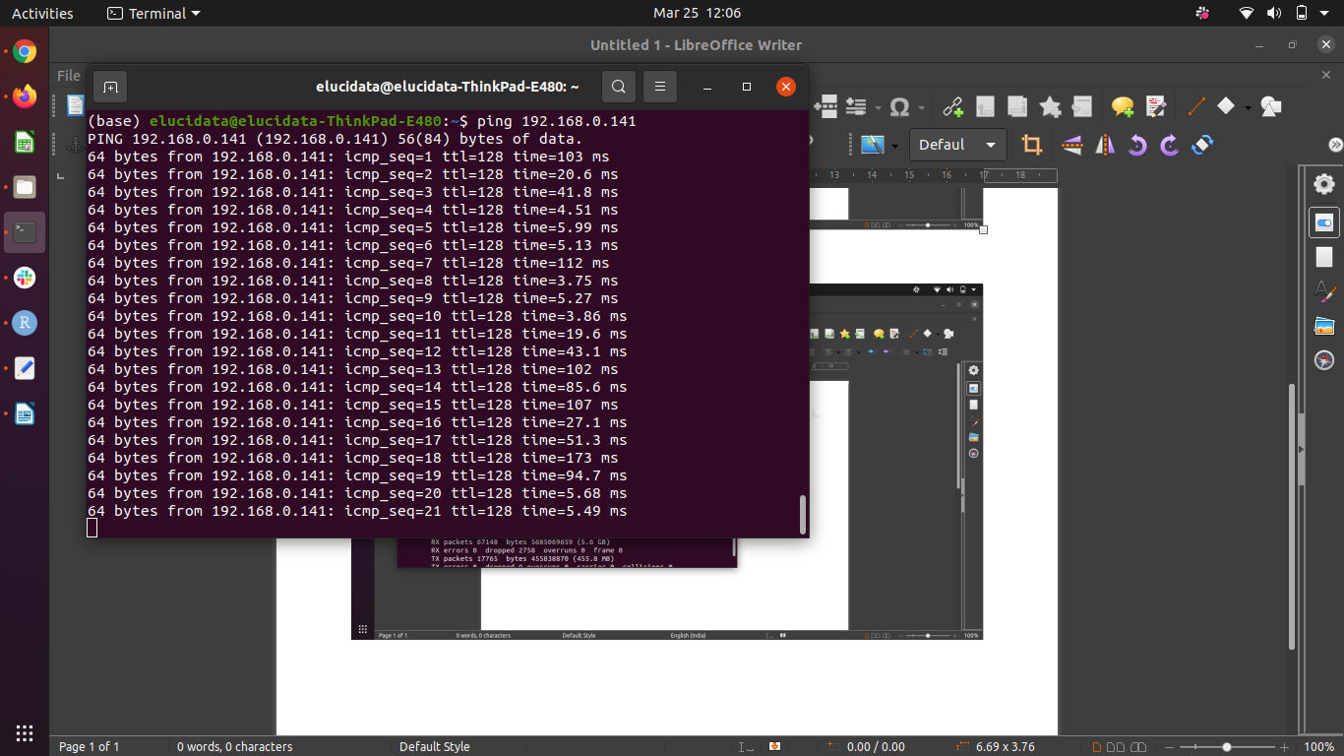**Ping**

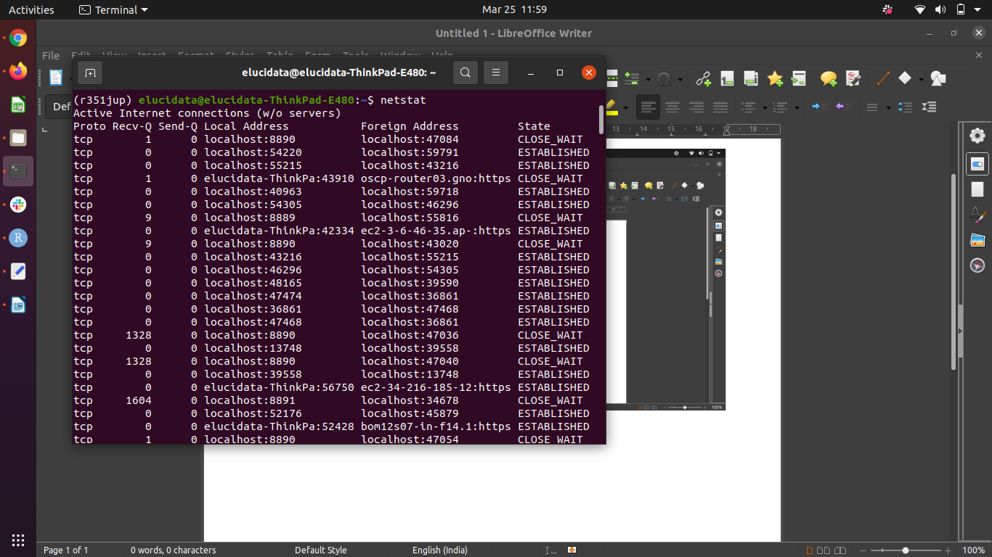**netstat**

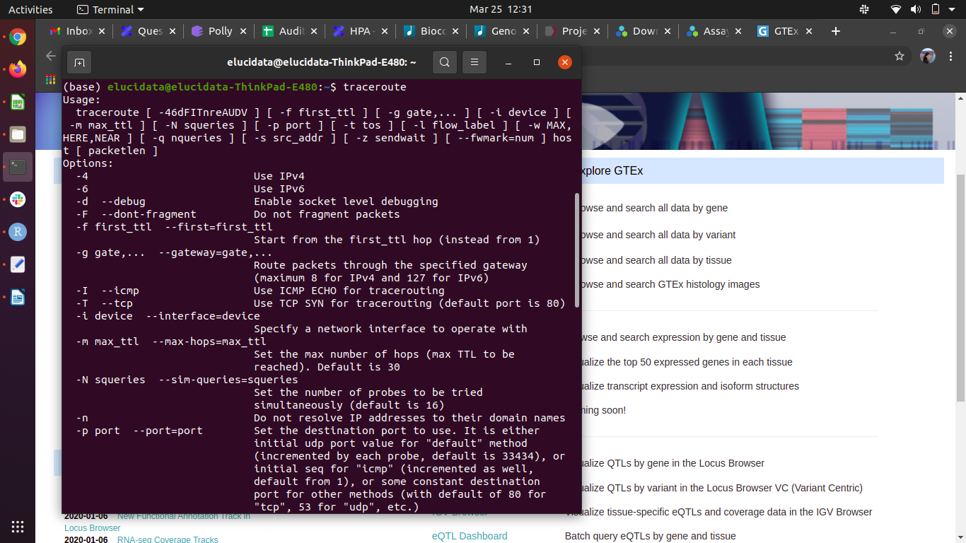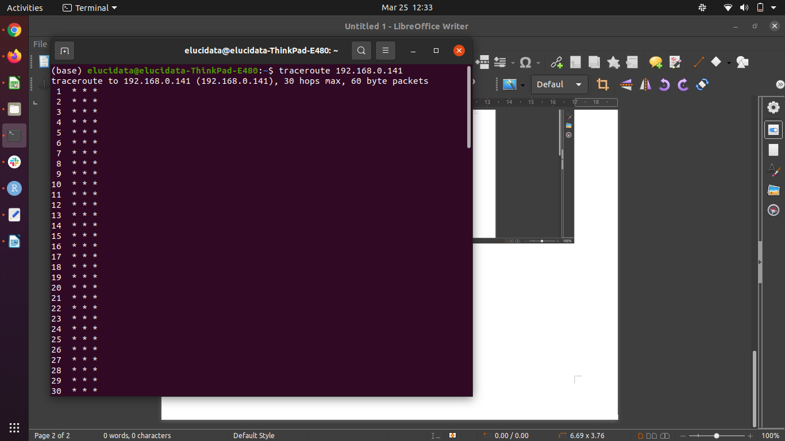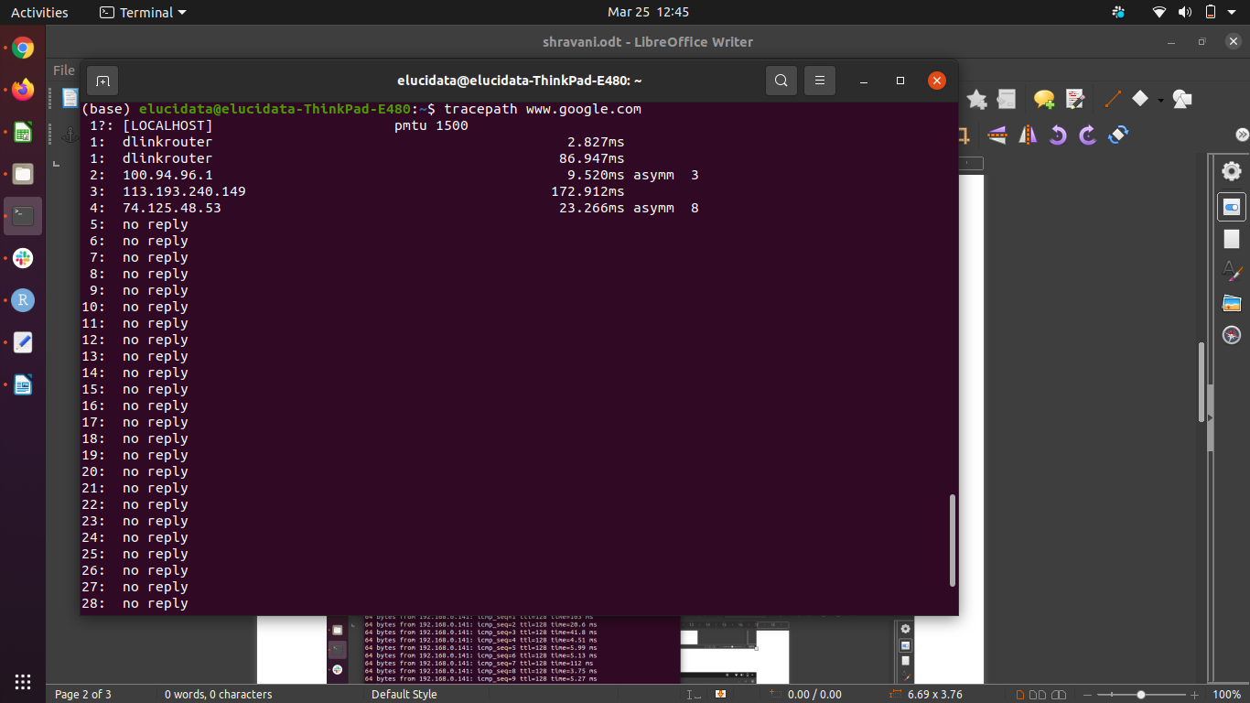**traceroute**

**B .ARP Poisoning**

**1.Open Cain & Able**

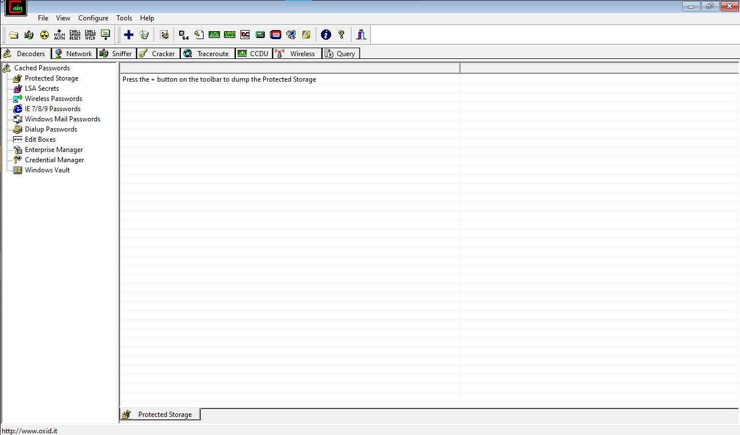

**2. Select Snipper Tab ,Click on start snipper**





**3. Go to Configure Tab ->Select any adapter and click OK**

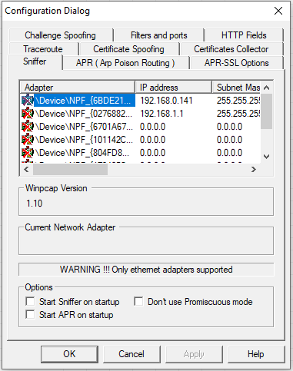

**4. Select All host in my subnet and click on OK**

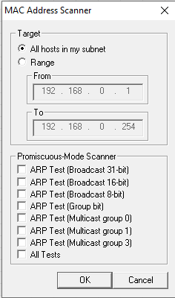

**5. After clicking OK it will list down the connected hosts information.**

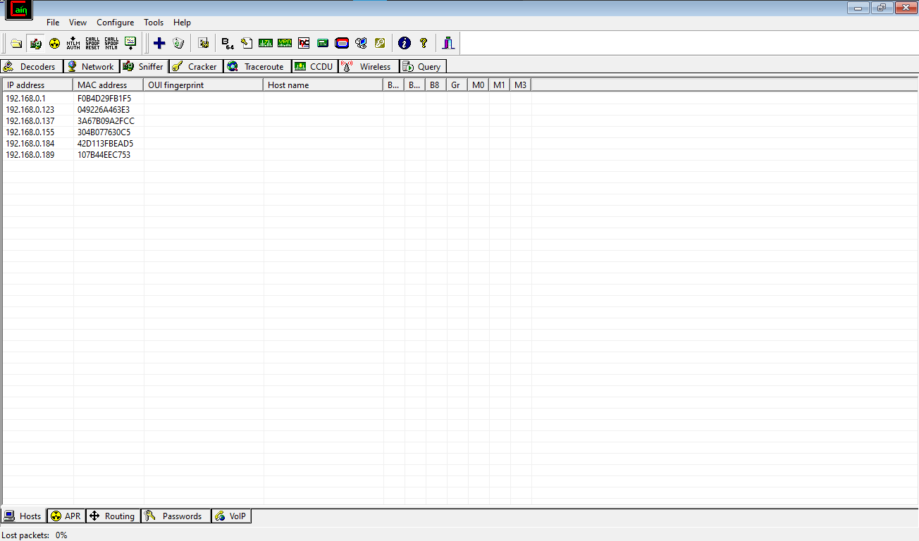

**6. Select APR tab**

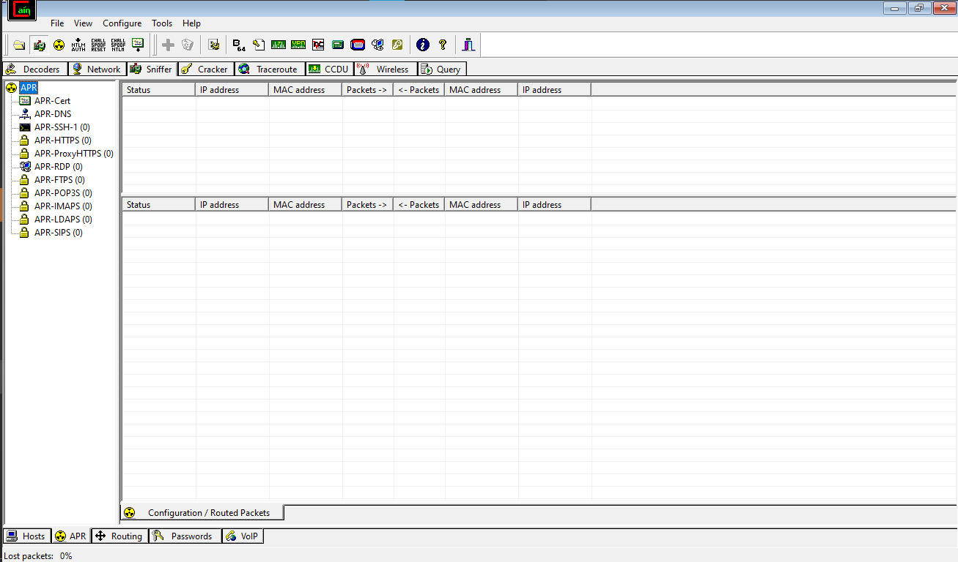

**7. Click on"+" icon and select the IPs and click on OK**

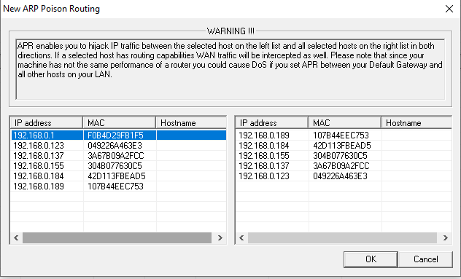

**8.Click on Start/Stop APR tab**

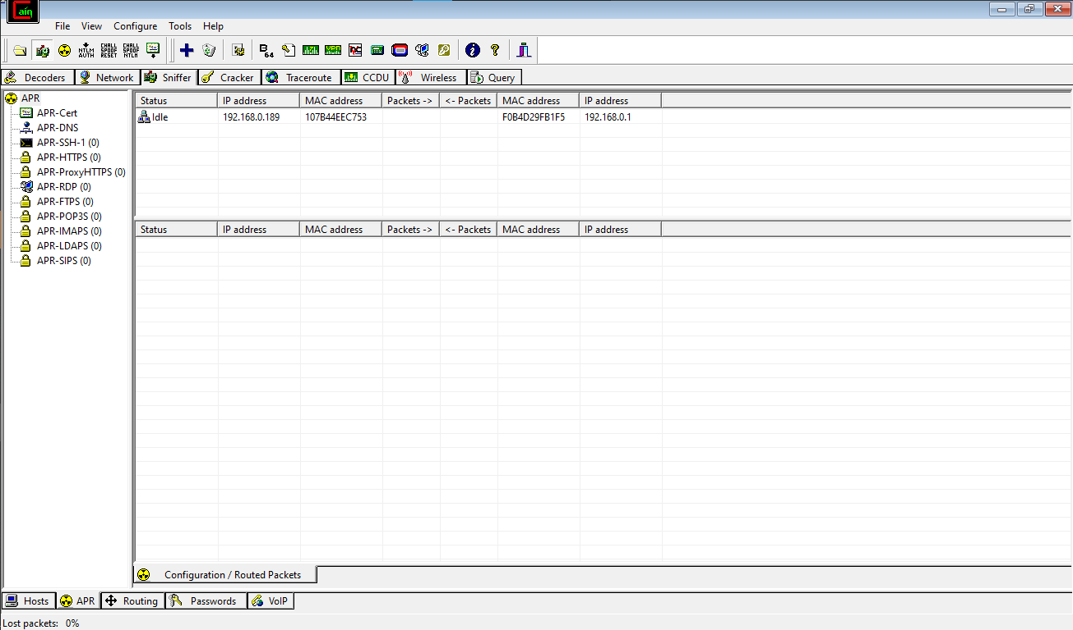

**9. Now it will start poisoning the selected source**

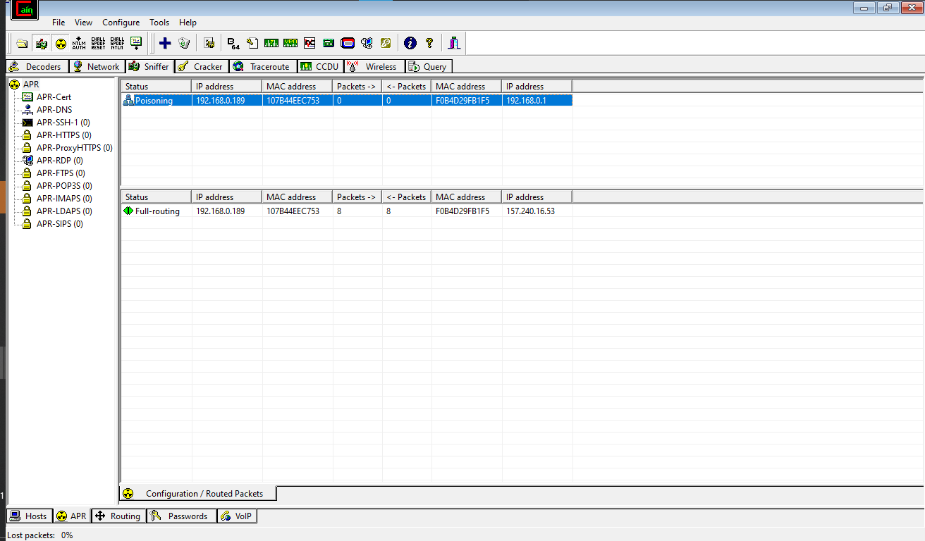

**10. Now go to the source IP Machine , Open Site ,enter the credential**

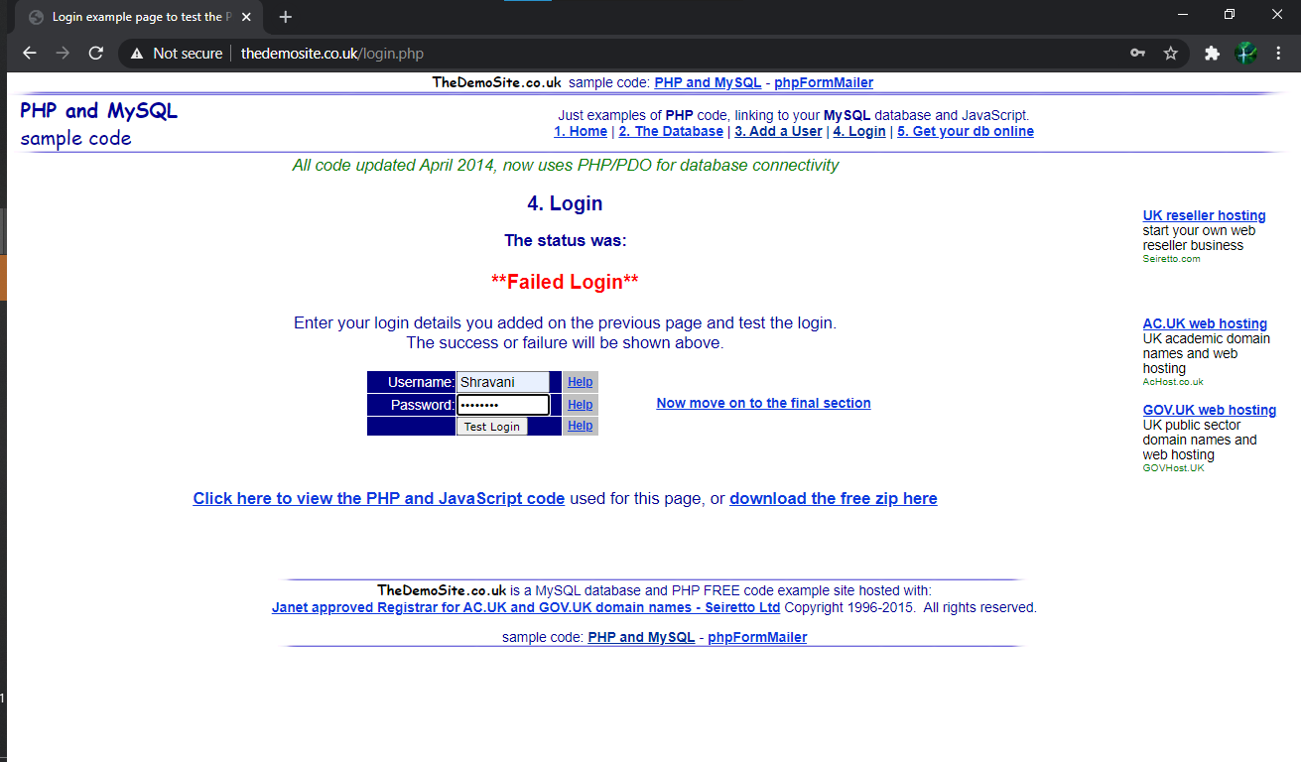

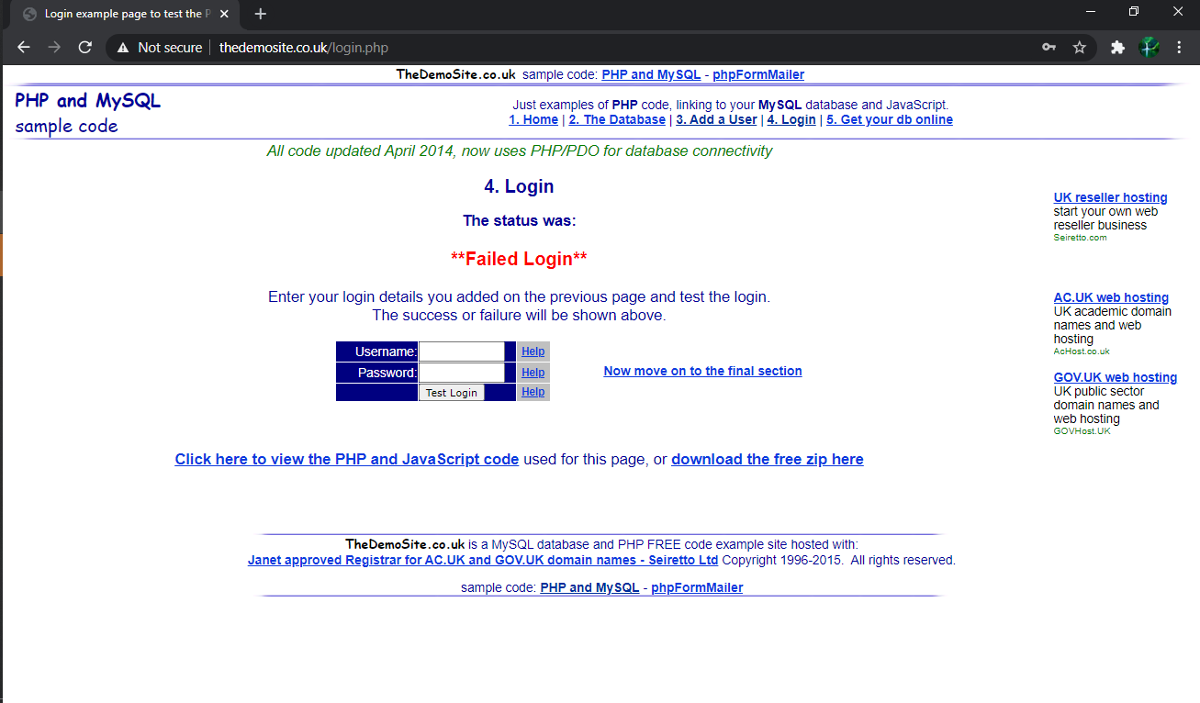

**11. Now go to password tab and select HTTP it will show the entered credentials**

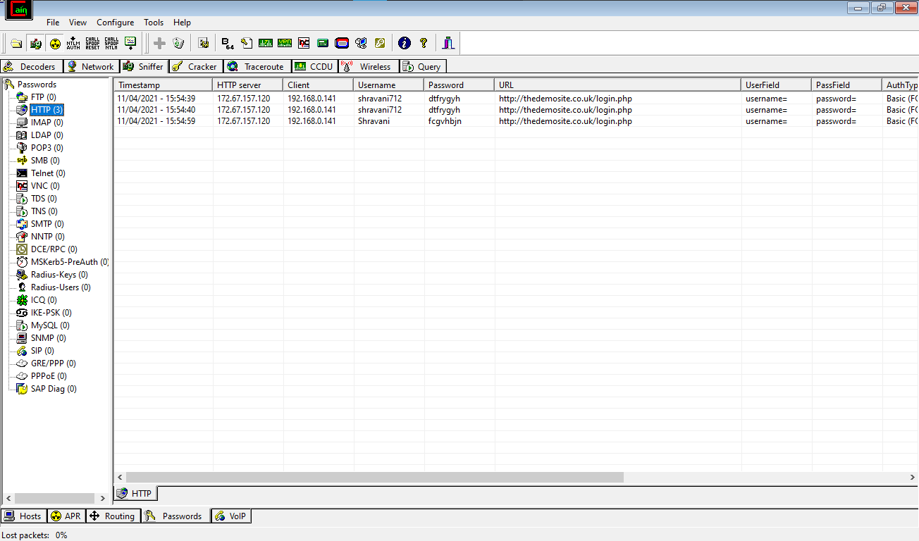

**Date:18/03/2021**

**PRACTICAL NO: 4**

**Aim:** Use NMap scanner to perform port scanning of various forms – ACK, SYN, FIN, NULL, XMAS

**1)ACK nmap –sA –p 22,25,53,70,80,113 scanme.nmap.org**

znmap] nmap –sA –p 22,25,53,70,80,113 scanme.nmap.org

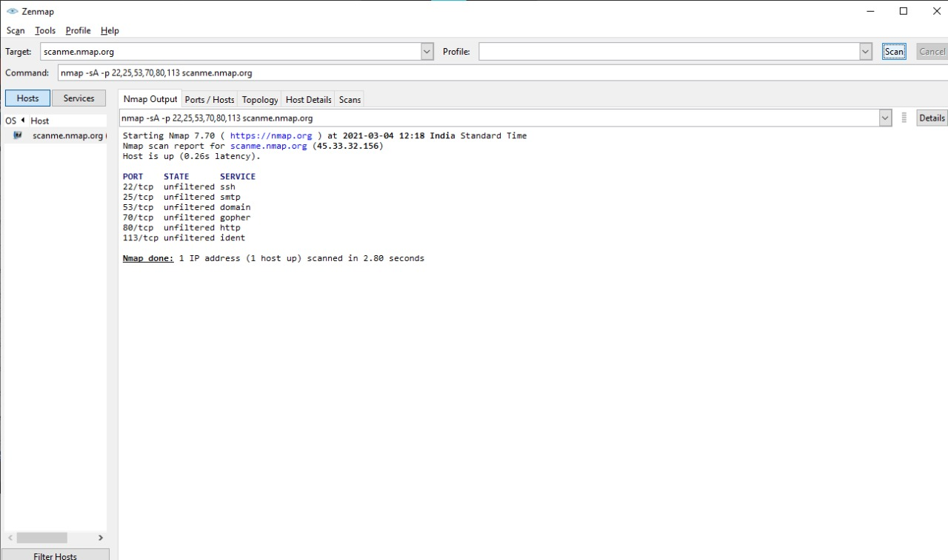

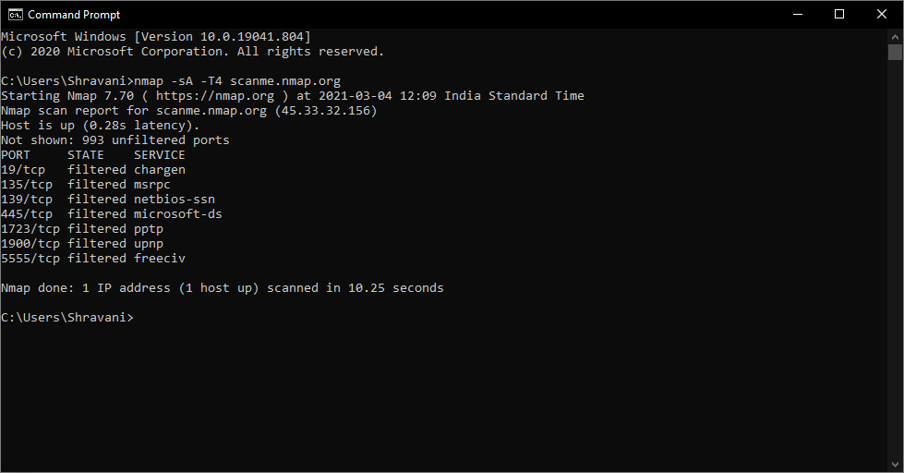cmd] nmap –sA scanme.nmap.org

**2)SYN nmap –sS scanme.nmap.org**

znmap] nmap –sS scanme.nmap.org

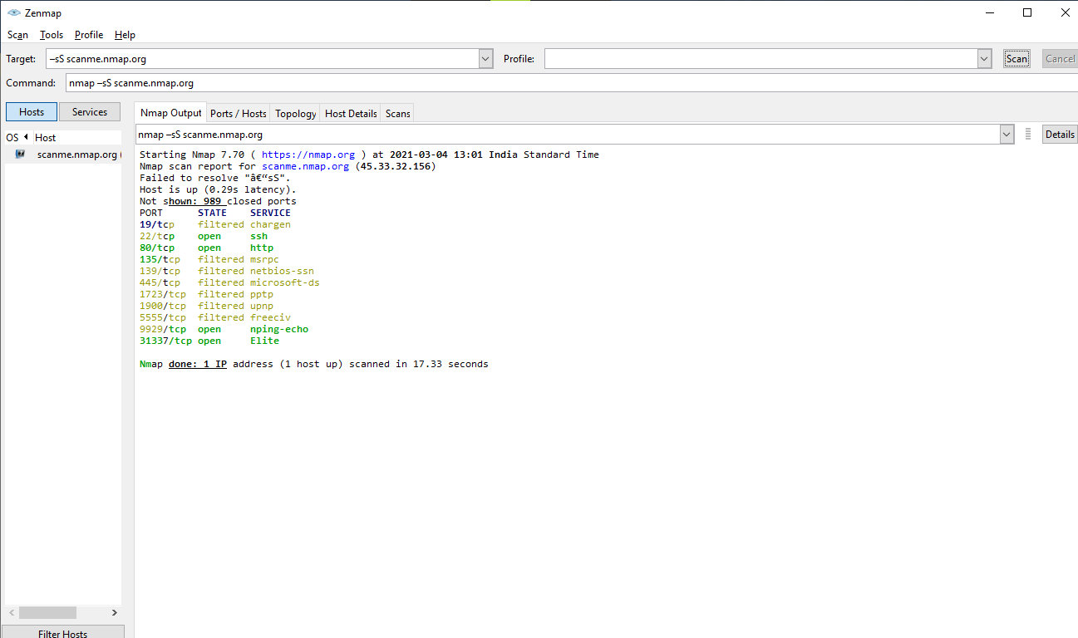

Cmd] nmap -sS scanme.nmap.org

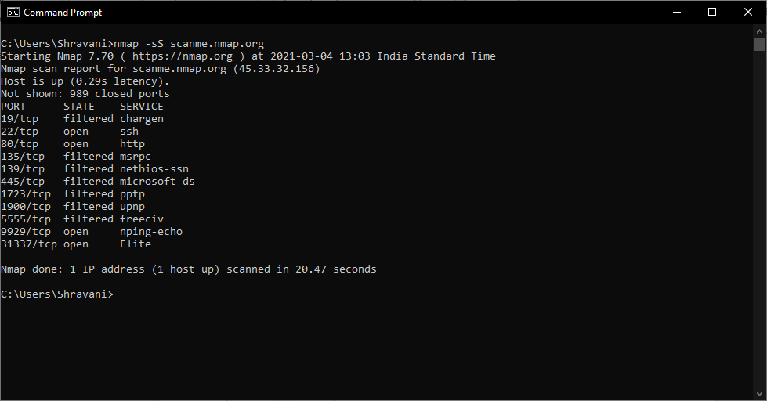

**3) FIN nmap –sF scanme.nmap.org**

Znmap] nmap –sF scanme.nmap.org

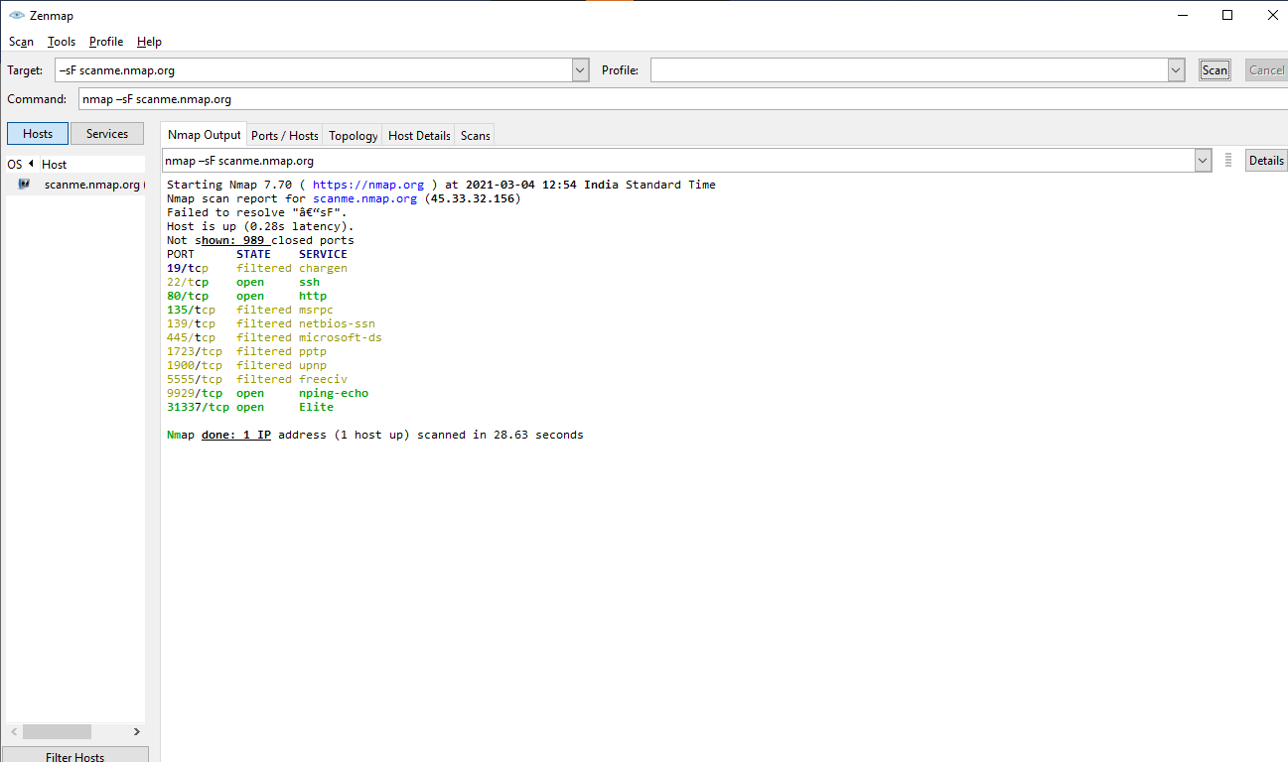

Cmd] nmap –sF scanme.nmap.org

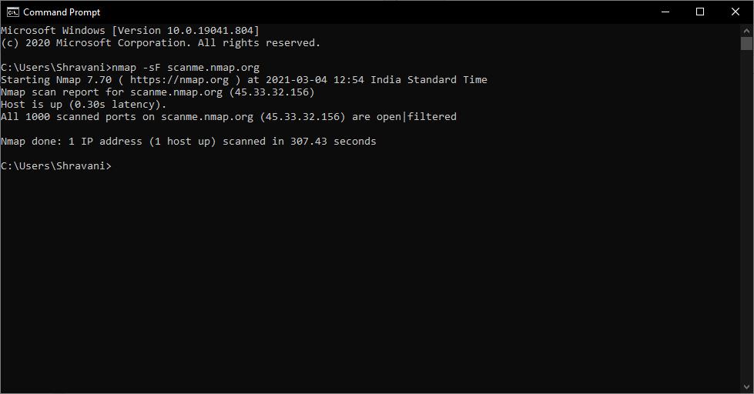

**4) NULL nmap –sN –p 22,113,139 scanme.nmap.org**

Znmap] nmap –sN –p 22,113,139 scanme.nmap.org

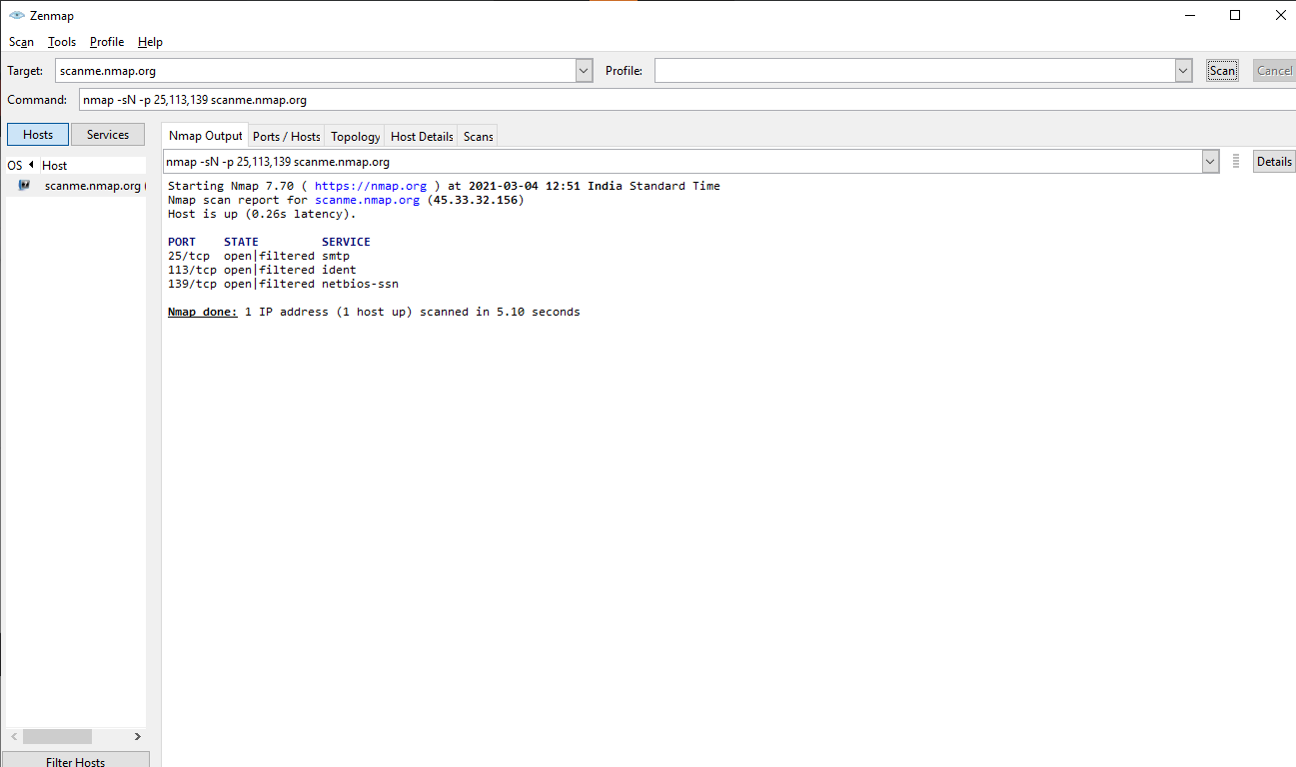

Cmd] nmap –sN –p 22,113,139 scanme.nmap.org

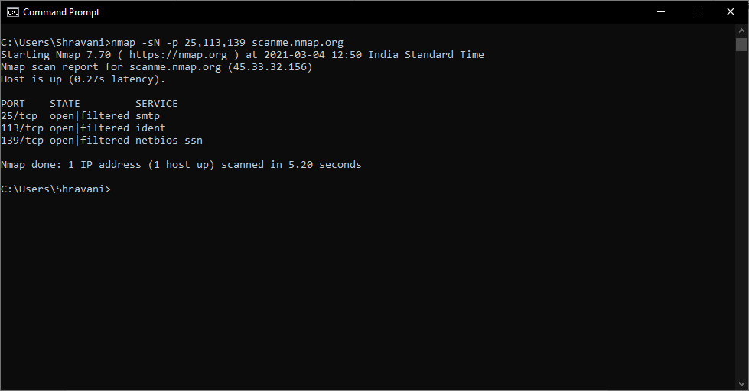

5] **XMAS nmap –sX scanme.nmap.org**

Znmap] nmap –sX scanme.nmap.org

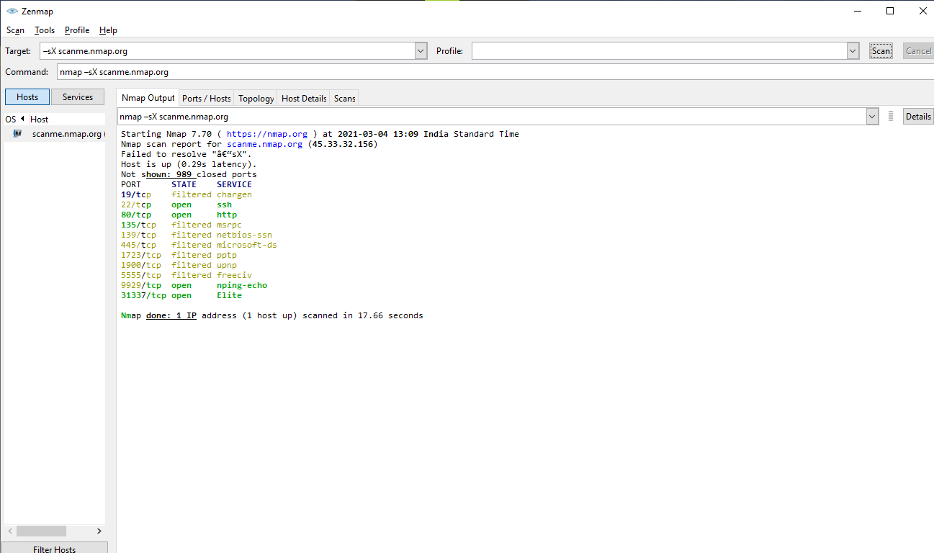

Cmd] nmap –sX scanme.nmap.org

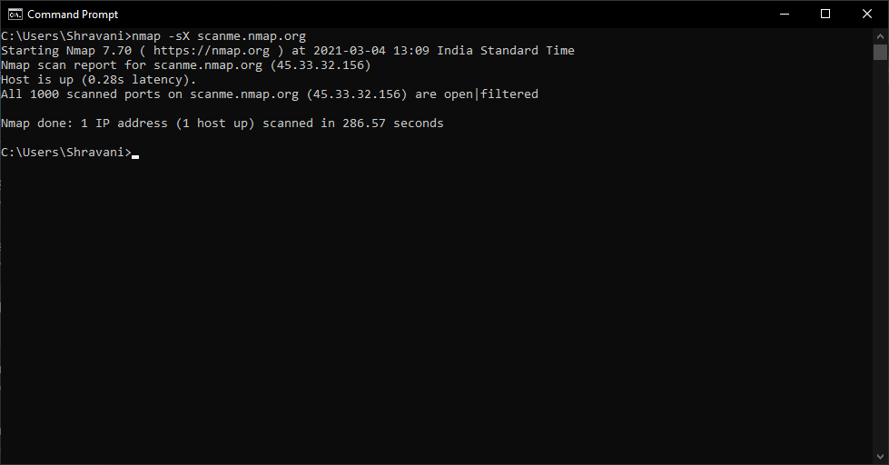

**Date:25/03/2021**

**Practical No: 5**

**Aim:** A) Use Wireshark (Sniffer) to capture network traffic and analyze. B) Use Nemesy to launch DoS attack.

**PART A: Use Wireshark (Sniffer) to capture network traffic and analyze .**

**STEPS:**

Step 1: Install any version of wireshark and Open it.

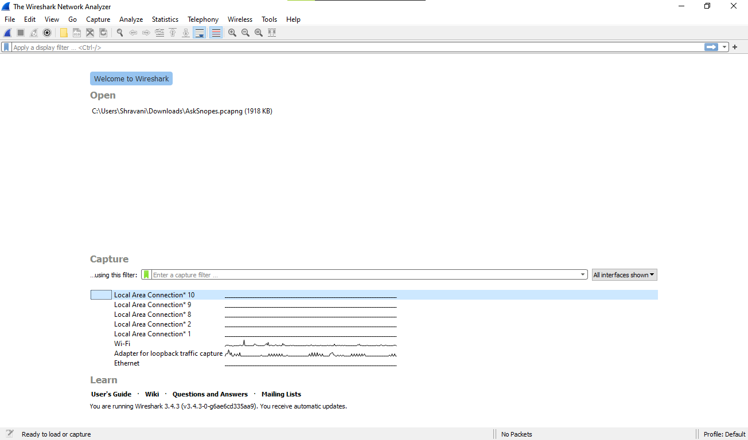

Step 2: Go to the Capture select the Option

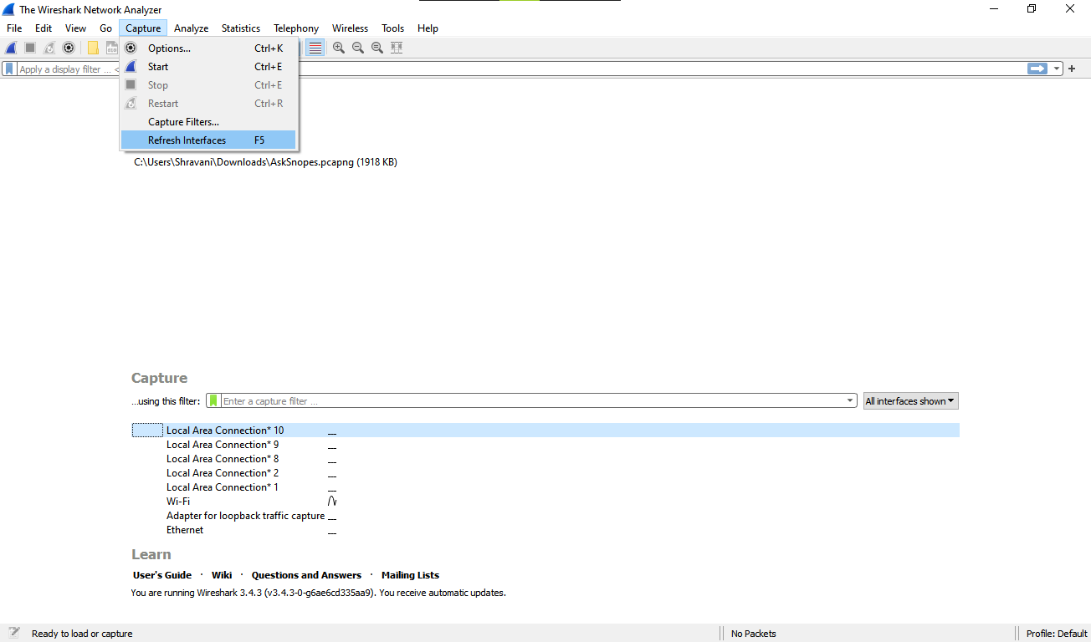

Now go to the wireshark, you can see the see the Source, Destination and Protocols of the packet(website) which you visited.

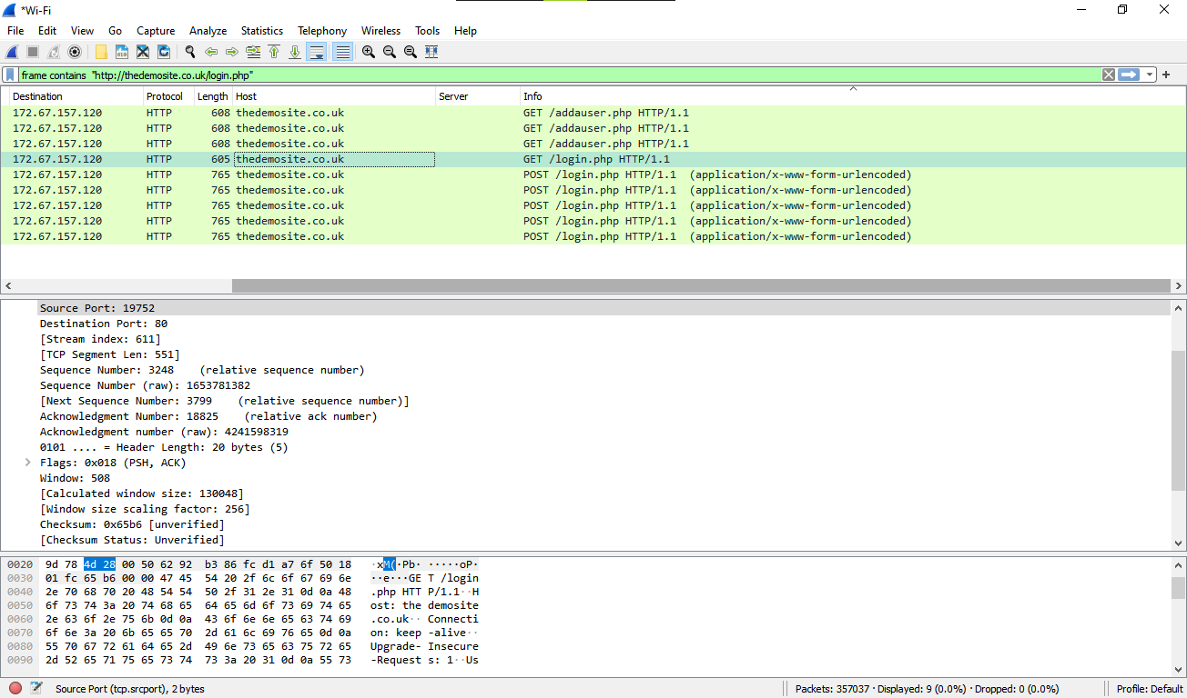

**Step 5:** Open a website in a new window and enter the user id and password. Register if needed.

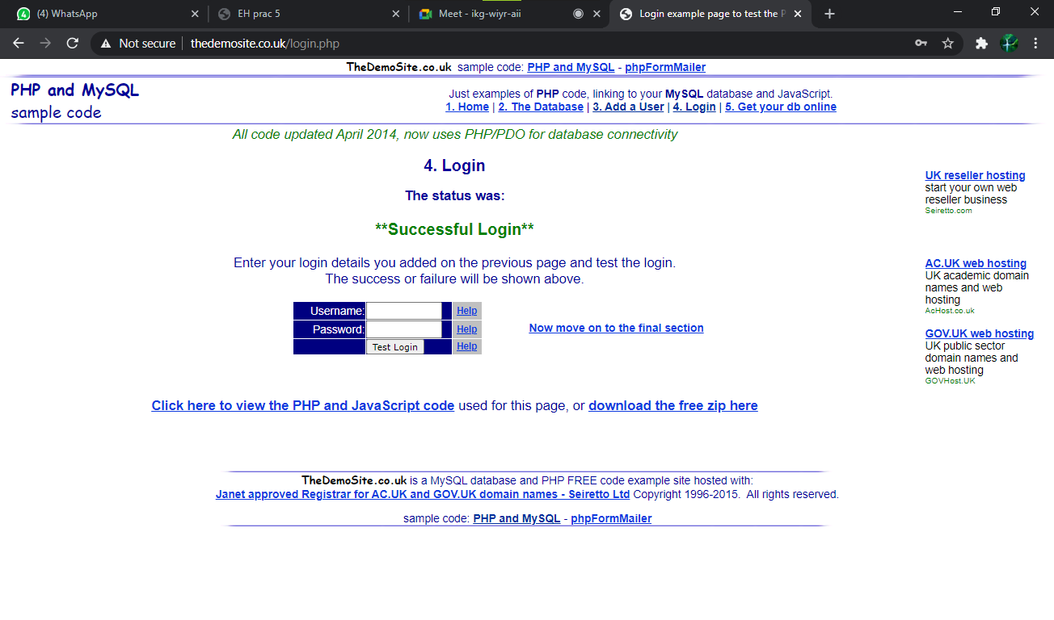

**Step 6:** Enter the credentials and then sign in.

F4e@SkmQ@25YKTT

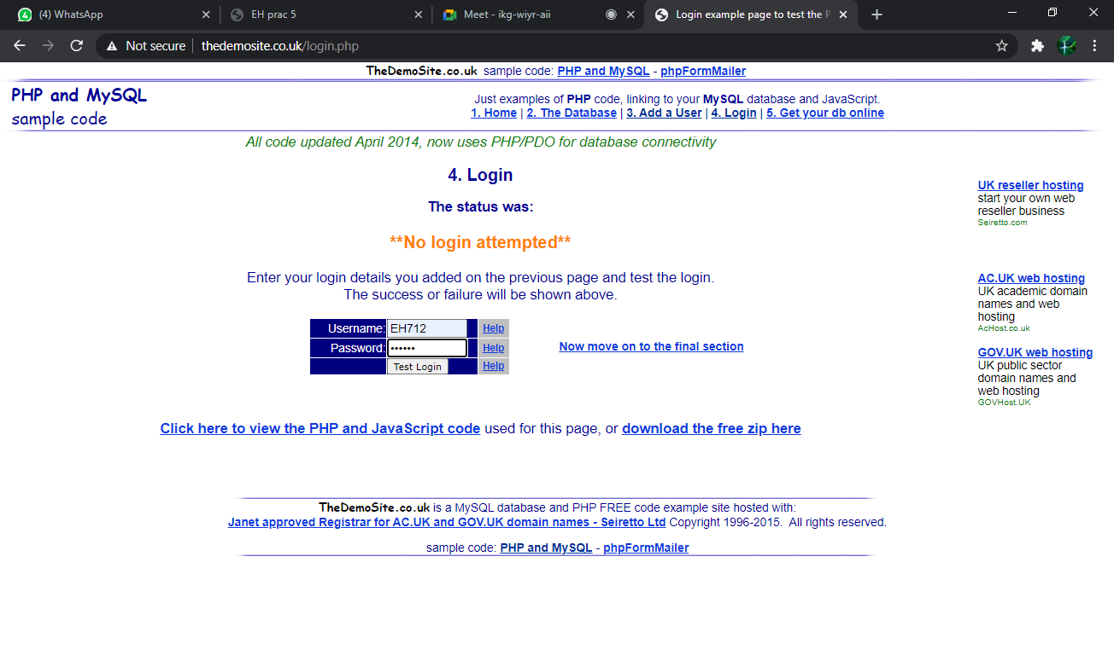

You can see in the wireshark that it will all the recording of the visited packets.

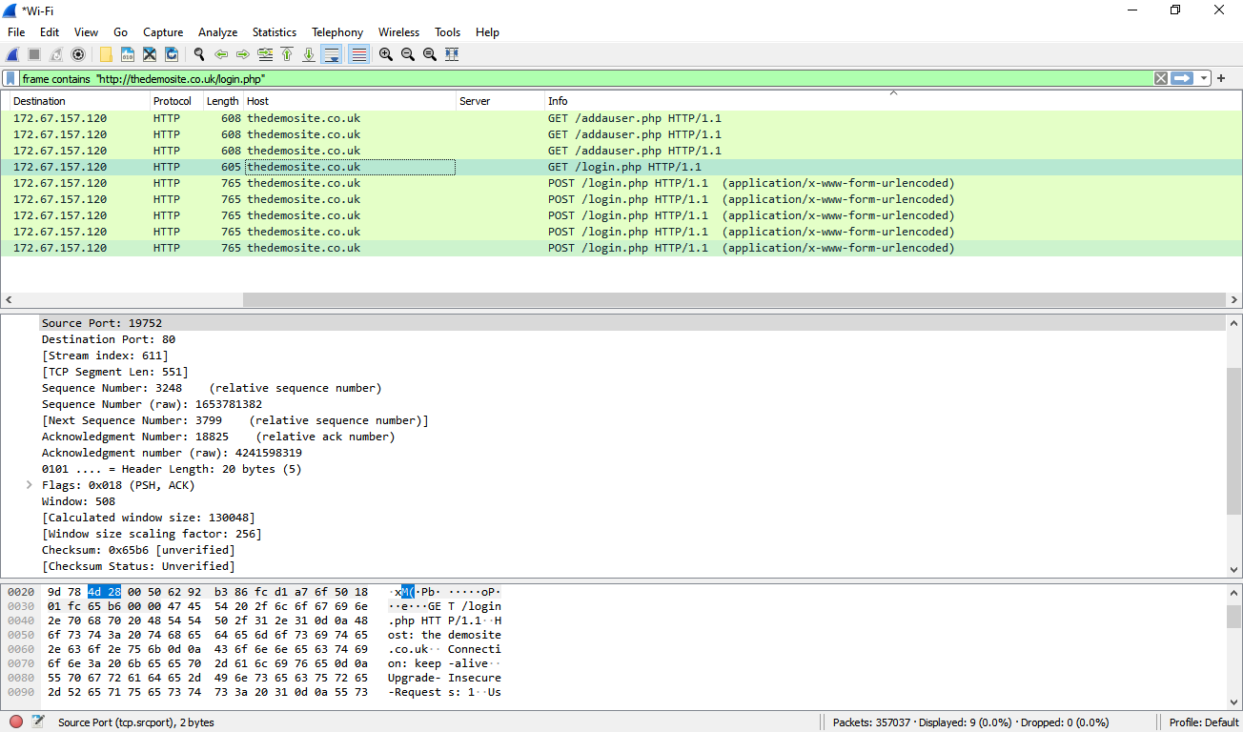

Step 8: Now in the wireshark tool check the second panel you get the POST method instead of GET method its mean now you can see your email id and password which you entered in the website.

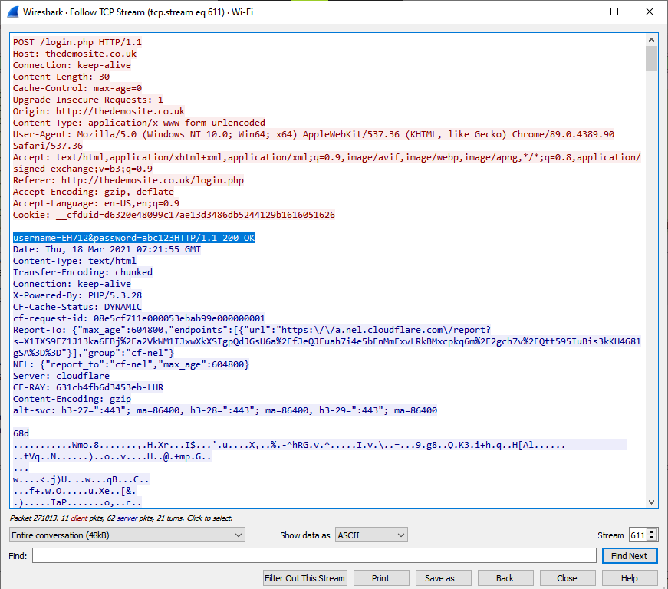

**PART B: Use Nemsey To Launch Dos Attack**

**STEPS:**

**Step 1:** Open the command prompt

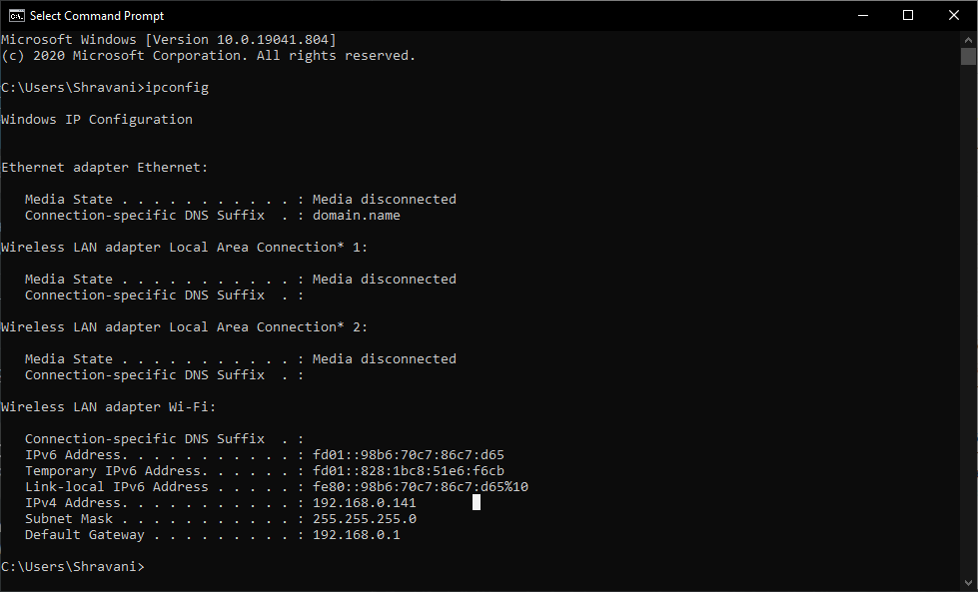

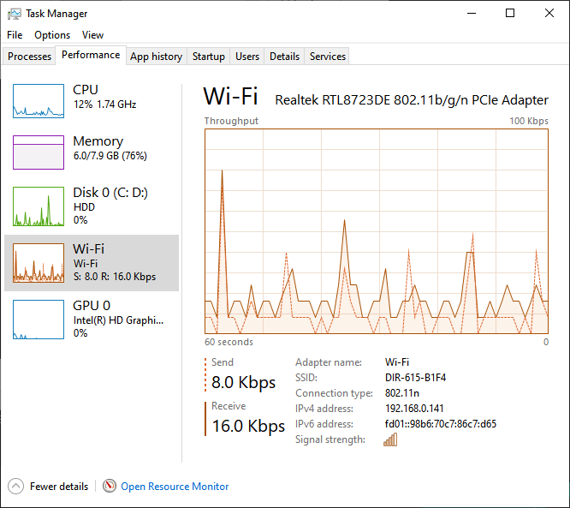

**Date:08/04/2021**

**Practical No: 6**

**Aim:** Simulate persistent cross-site scripting attack.

**Prerequisites:**

* DVWA.zip file.
* XAMPP Server.

**Steps**

**Step 1 :** Install **XAMPP Server** and Open it **->** Start **Apache** and **MySql**.

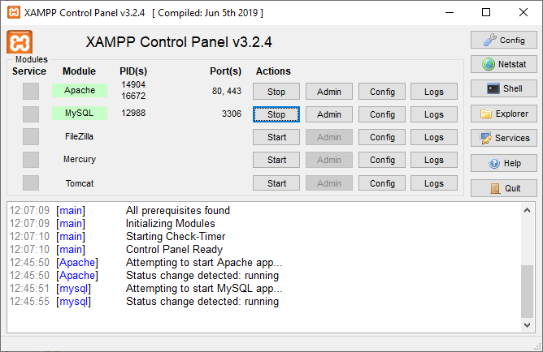

**Step 2 :** Extract the downloaded file and then copy paste the **DVWA** folder in **C:\xampp\htdocs**.

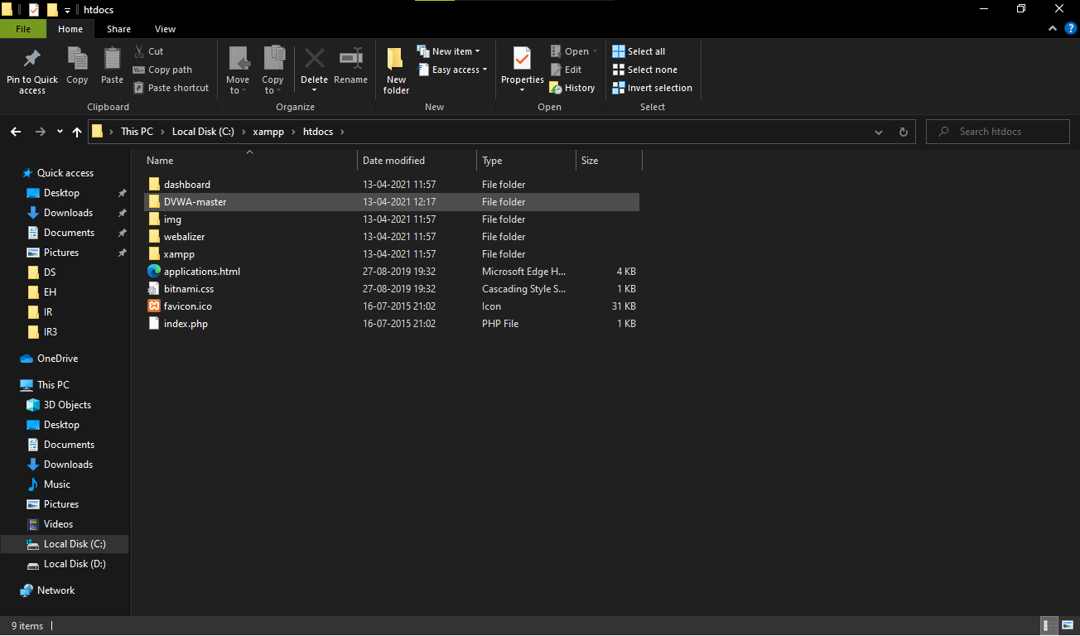

**Step 3 :** Go to **C:\xampp\htdocs\DVWA\config** and copy **“config.inc.php.dist”**

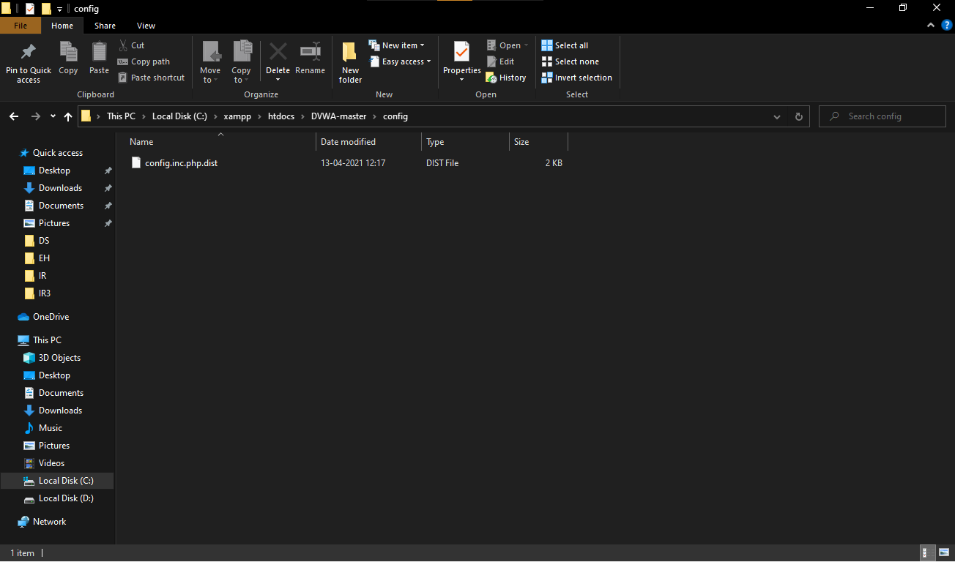

**Step 4 :** copy **“config.inc.php.dist”** andrename to **“config.inc.php”**.

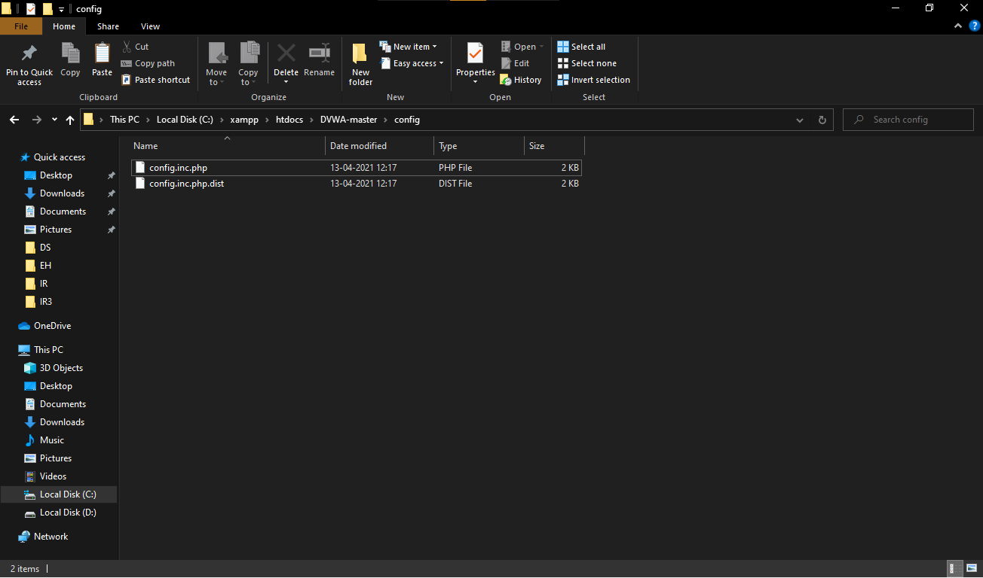

**Step 5:** Open the file in notepad and clear the password and save it.

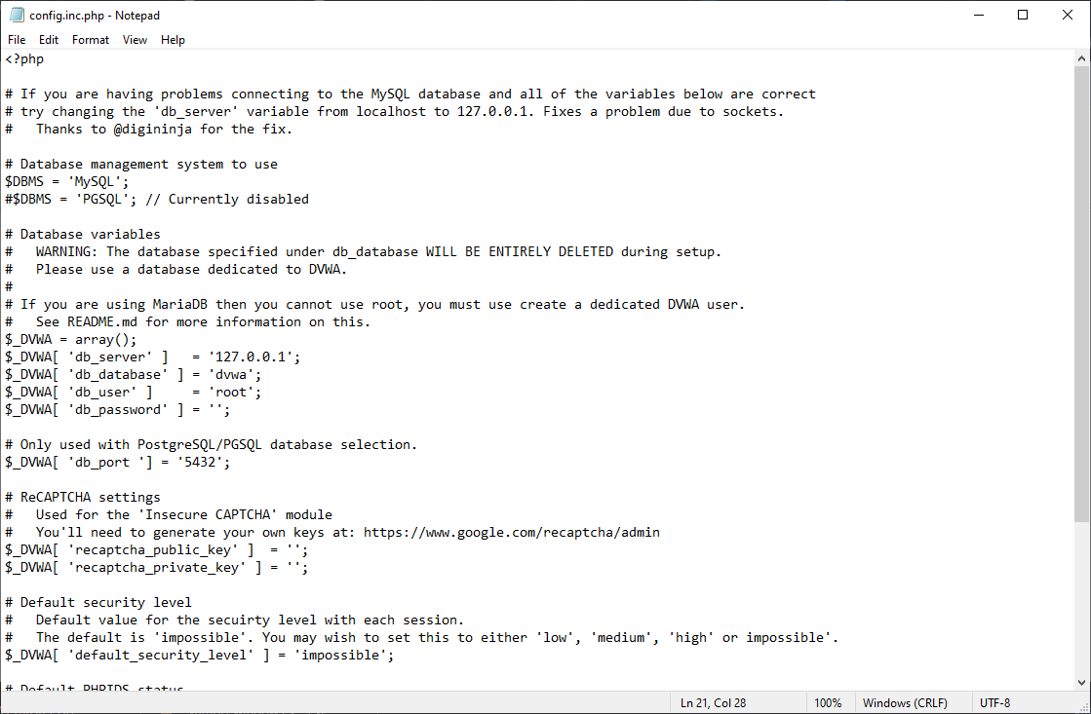

**Step 6 :** Now go to browser and search **localhost/DVWA-master/setup.php** below window will appear.

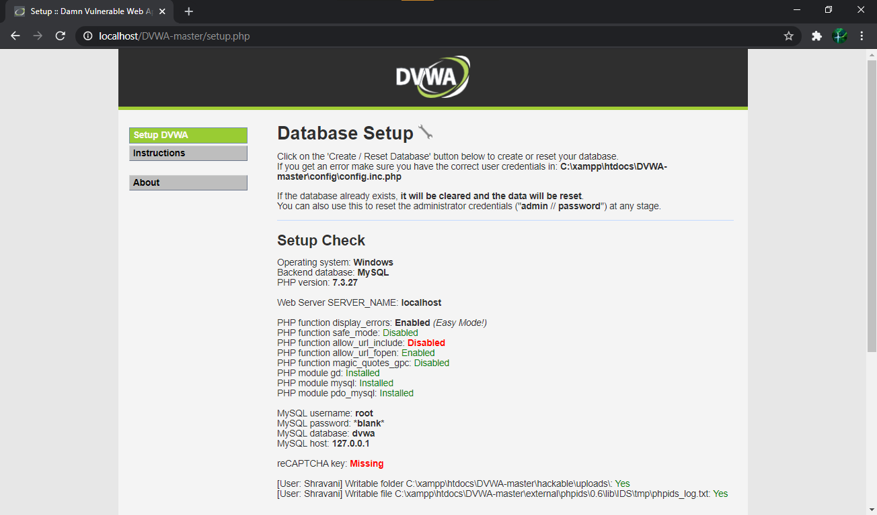

**Step 7 :** Scroll down the page click on **Create/ Reset Database ->** Database will be created and Click on login.

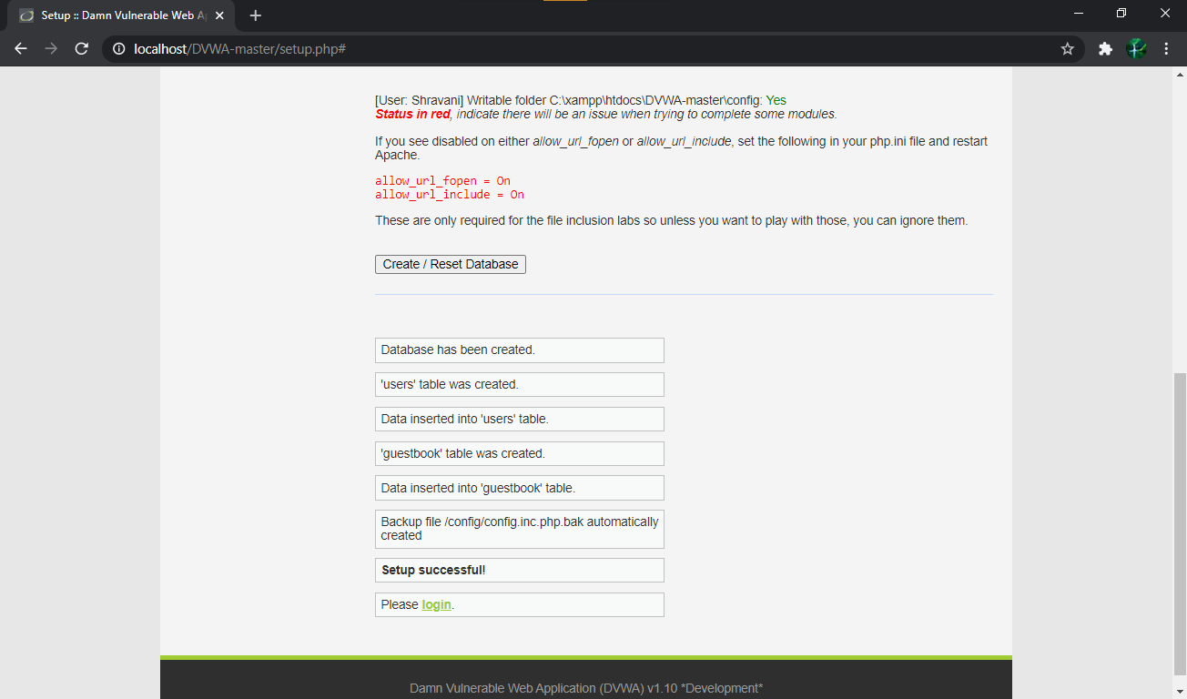

**Step 8 :** You will be directed to **localhost/DVWA/login.php ->** Enter **Username** as **“admin”** and **Password “password”.** You will be Logged in

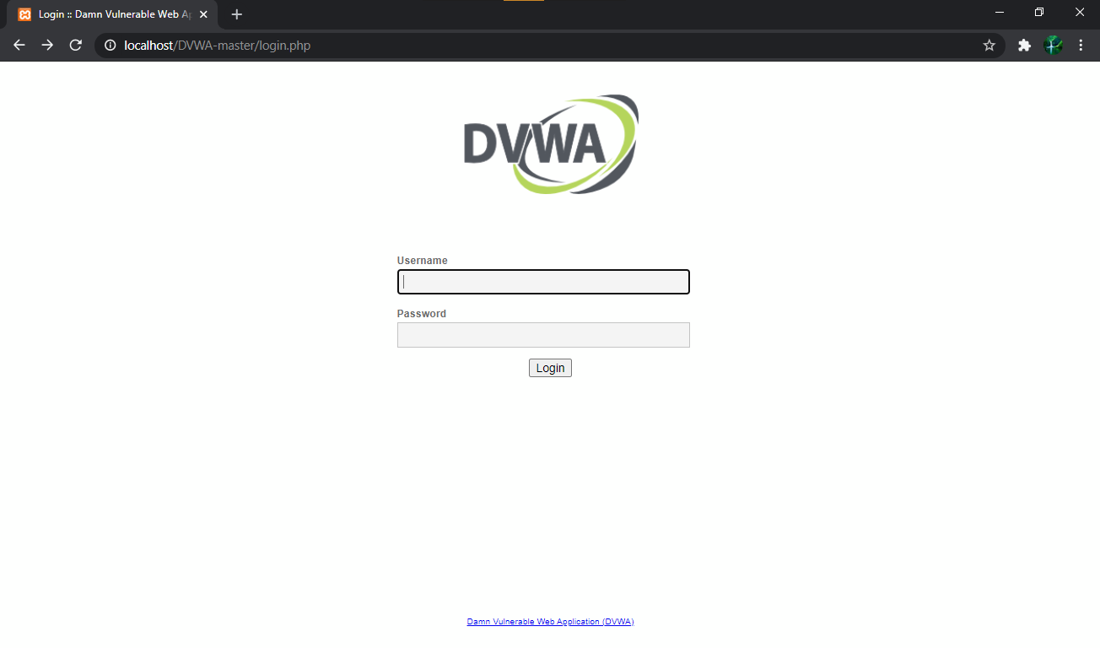

**Step 9 :** After logged you will redirect the below window:

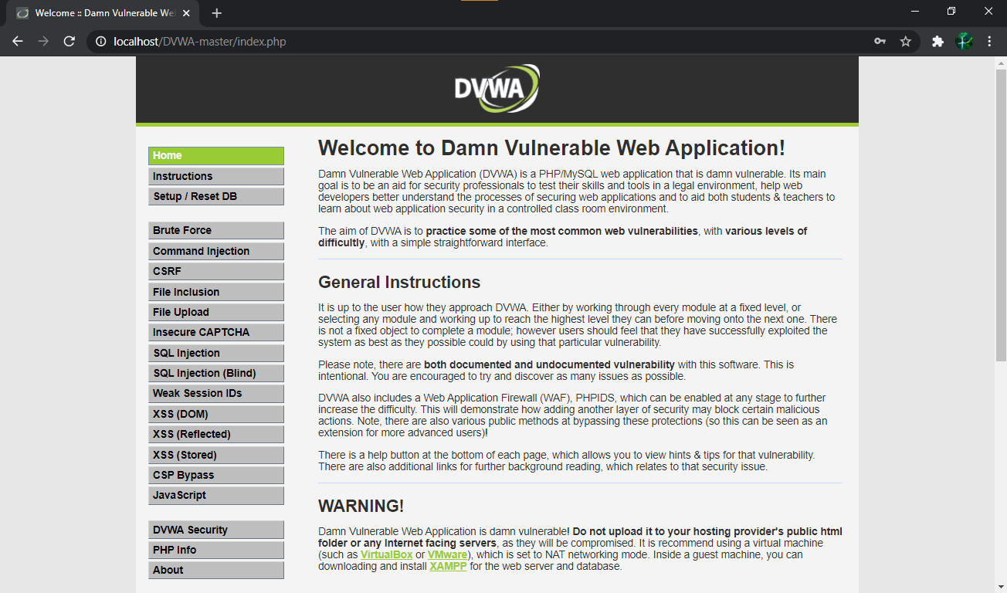

**Step 10 :** NowClick on **DVWA Security ->** Select security as **Low** and **Submit.**

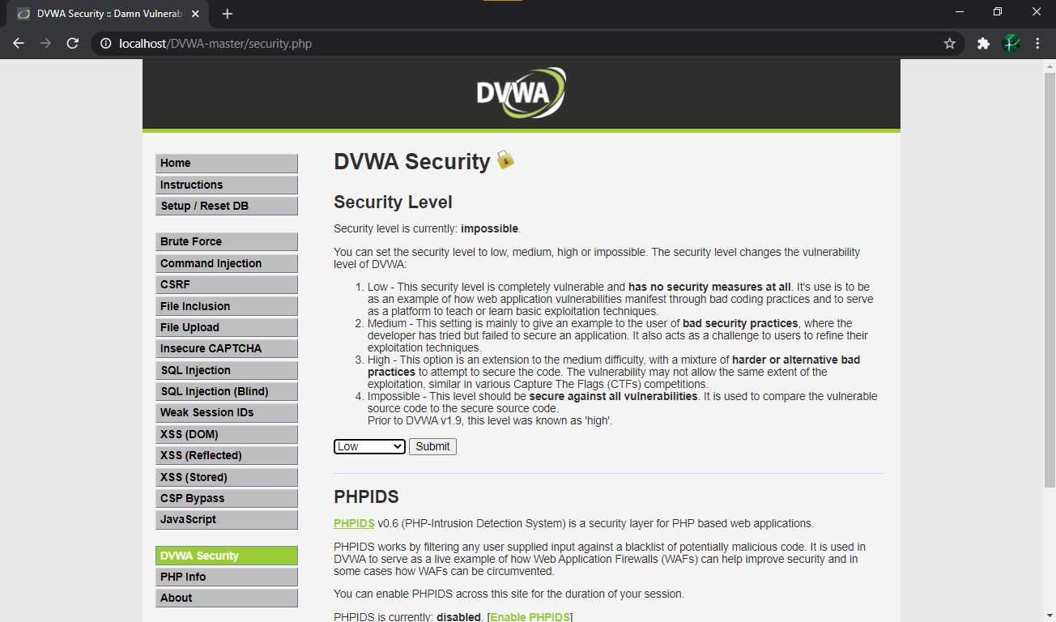

**Step 11 :** Click on **XSS (Stored) ->** Fill theNameand write script code inMessageas follows :

<script>alert("Hello xss file")</script>

Click on Sign Guestbook

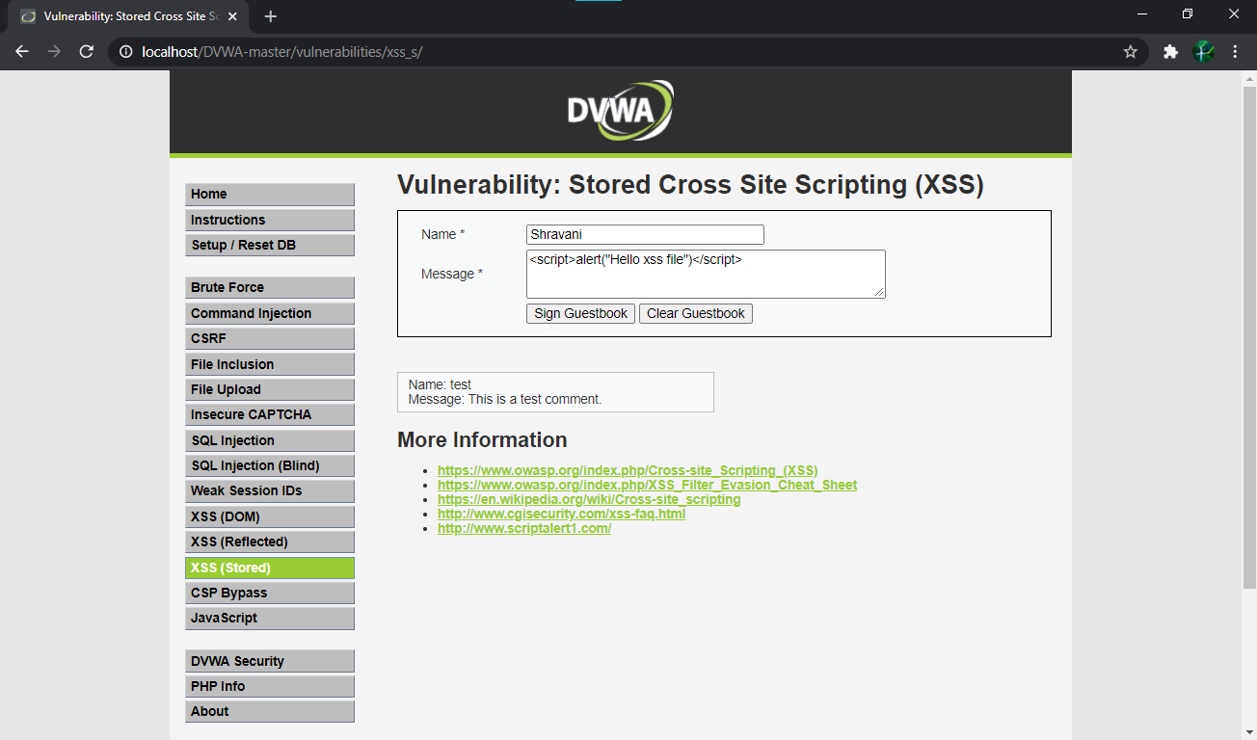

**Step 12 :** When you click on “Sign Guestbook” your alert message will pop-up on screen

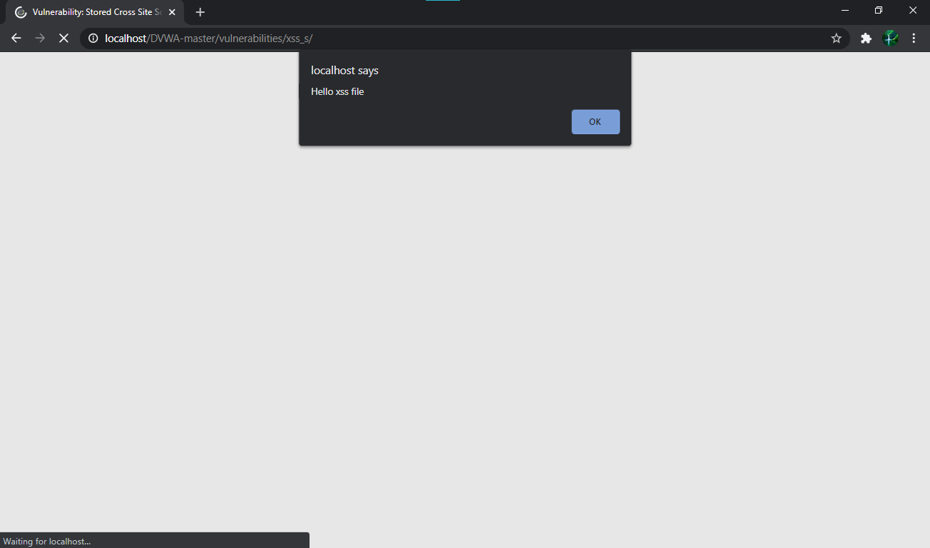

**Step 13 :** Now again fill thenameand write script code inMessageas follows

<script>alert(document.cookie)</script> and Click on Guestbook.

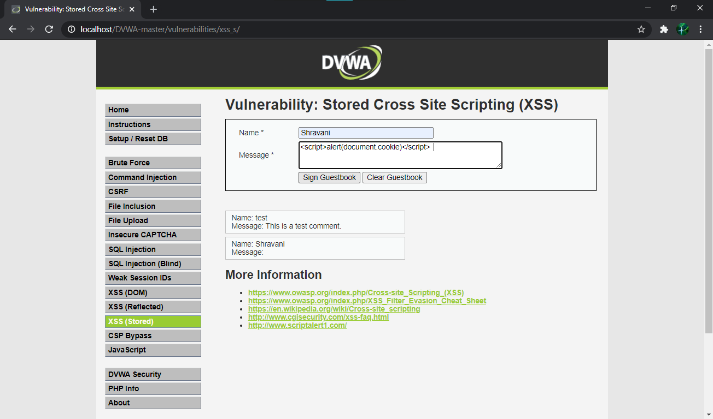

**Step 14 :** This time some id will pop-up on the window.

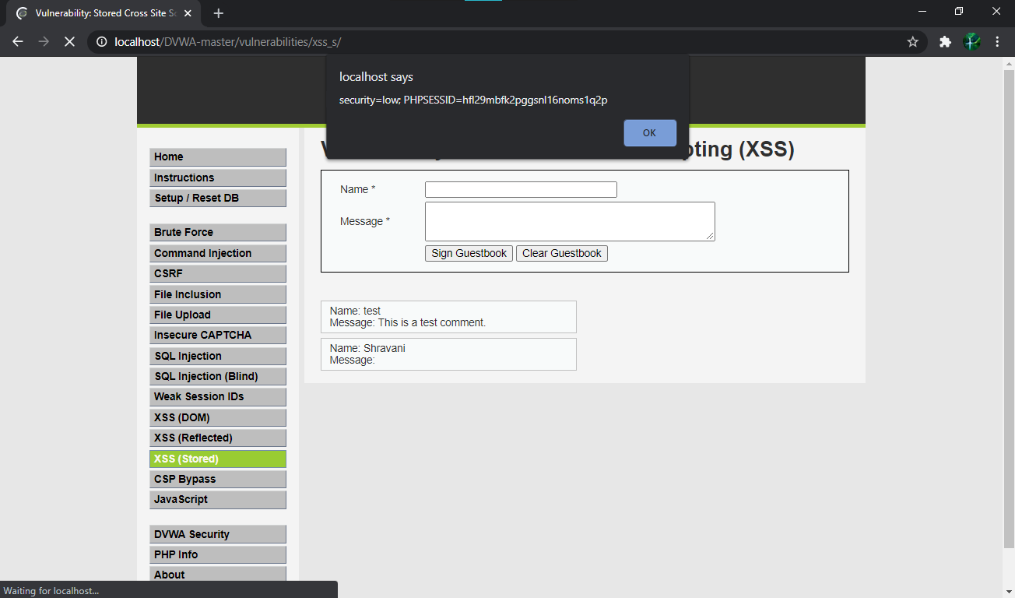

**Date:12/04/2021**

**Practical No: 7**

**Aim:** Session impersonation using Firefox and Tamper Data add-on.

**PREREQUISITES:**

Cookie Editor Extension.

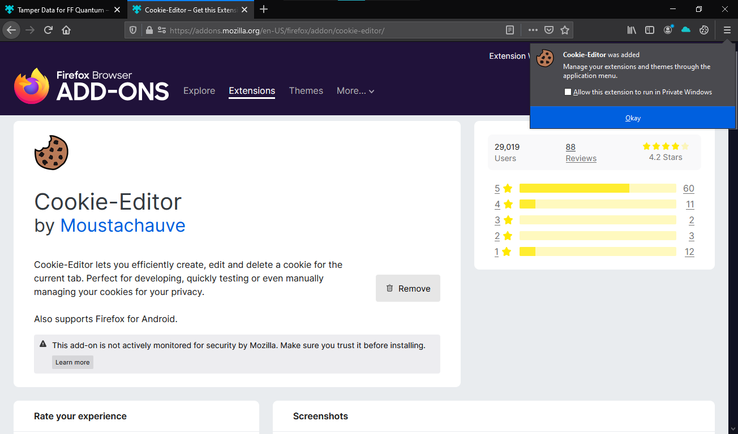

Tamper Data Extension

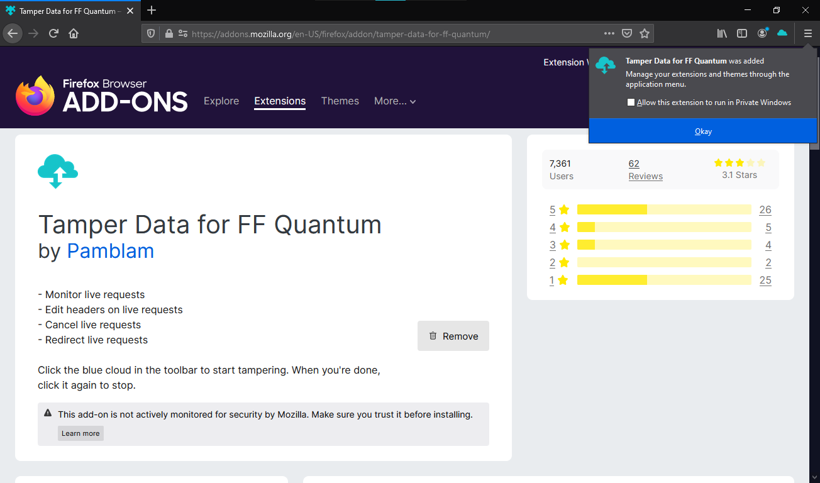

**STEPS:**

1.After downloading both the add-ons. In new tab: open <http://www.techpanda.org/>. &. Enter Email as: [*admin@google.com*](mailto:admin@google.com) and Password as: *Password2010*. Click on Submit.

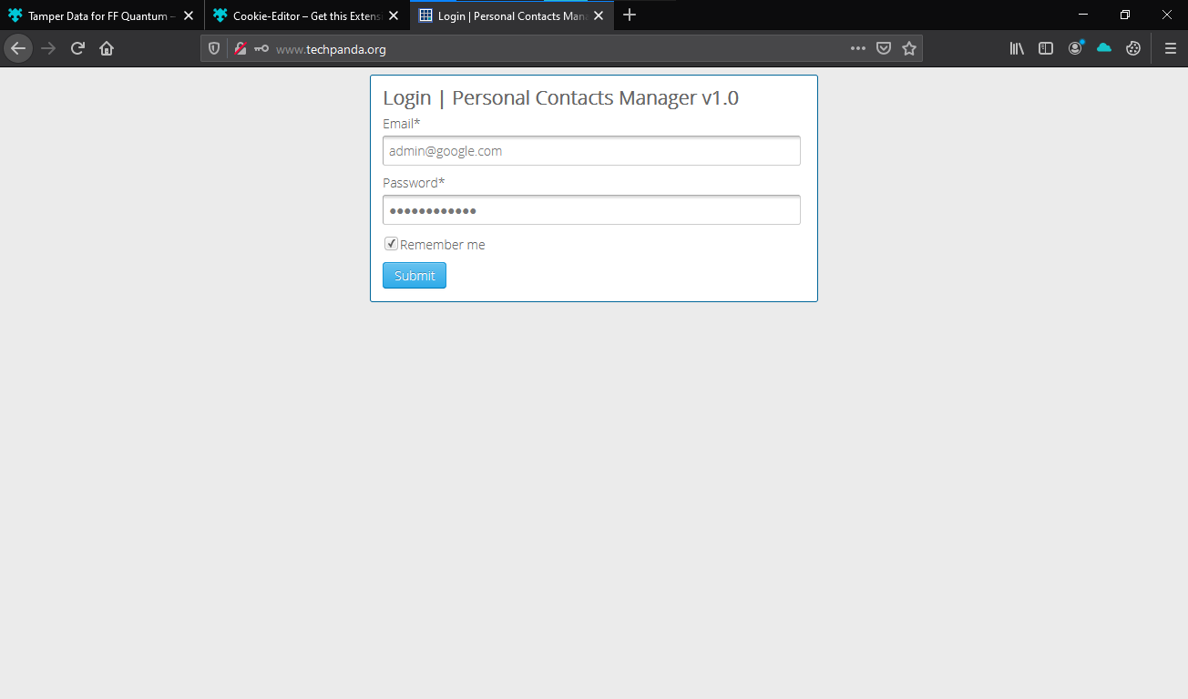

2 You will be logged in the site.

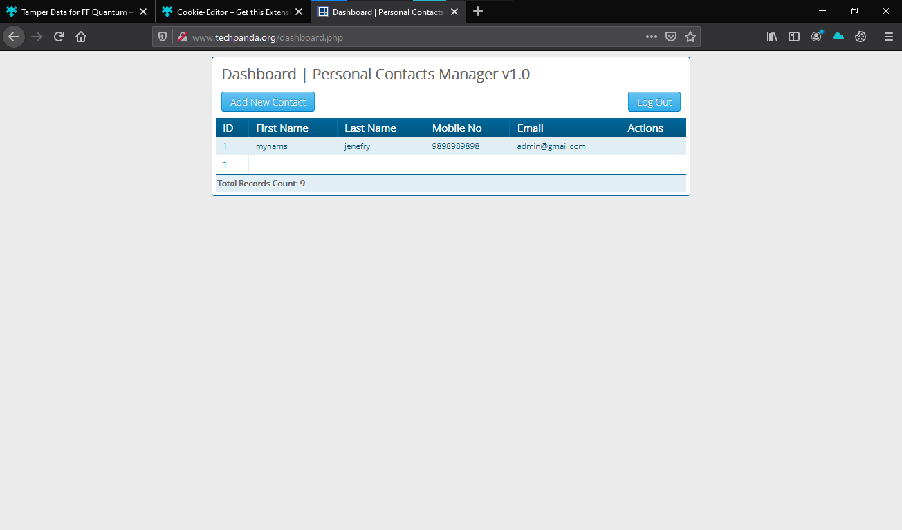

3. It Will be redirected to Dashboard → Go to Cookie editor add-on at top-right and in PHPSESSID Copy session id displayed in Value. uoqaju5btsj5rqsmoso084fd51

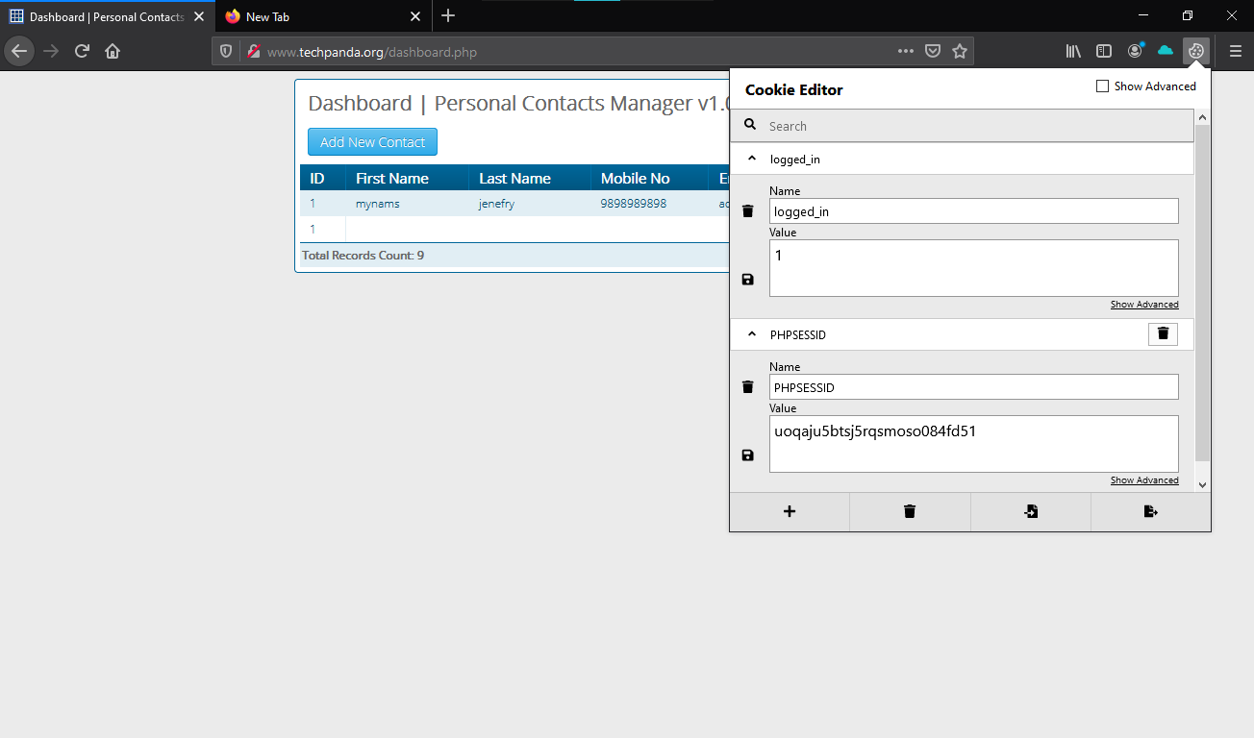

4. Don’t log out and close the tab. Go to options/privacy/remove individual cookies and delete the cookie(s).

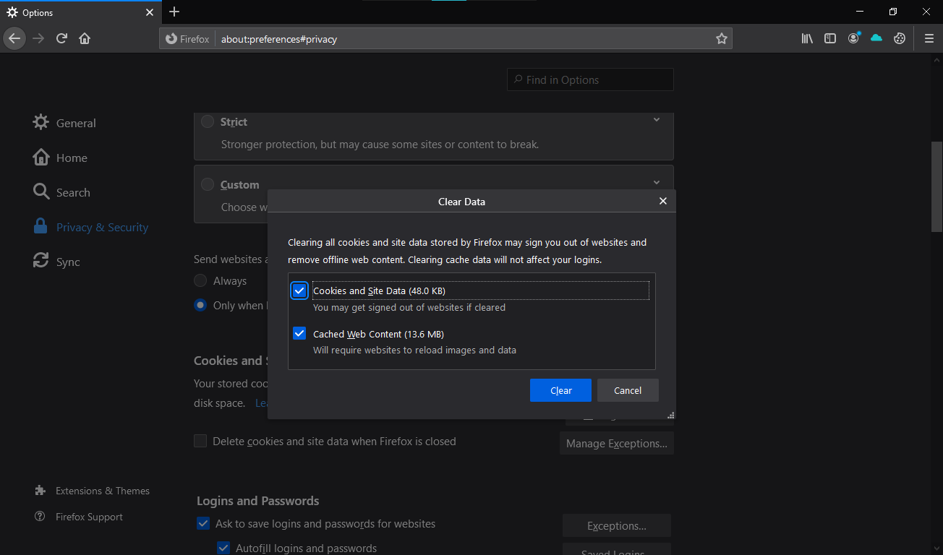

5. Start Tamper Data and click on Yes.

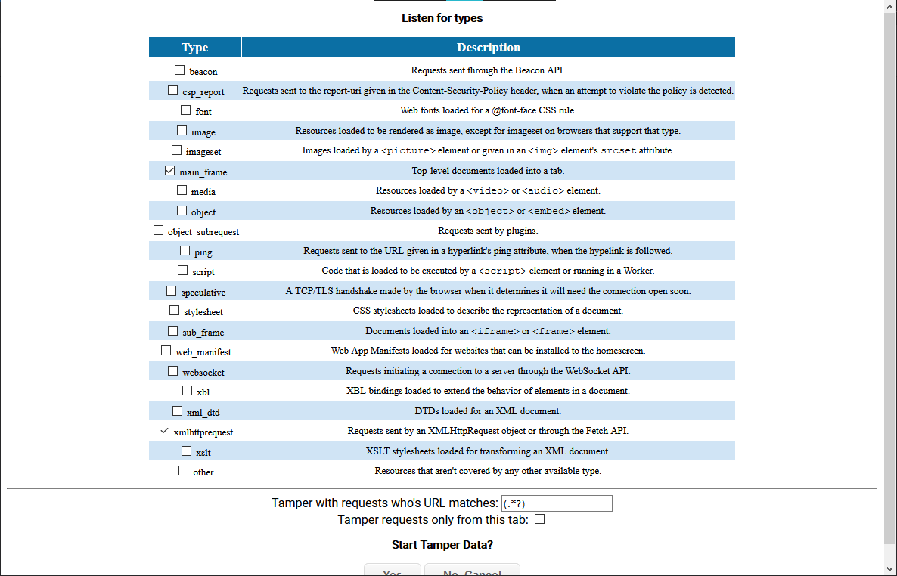

6. Next, click on Ok.

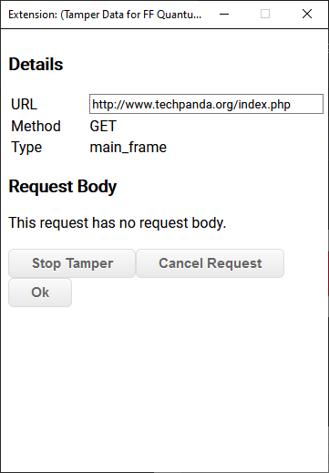

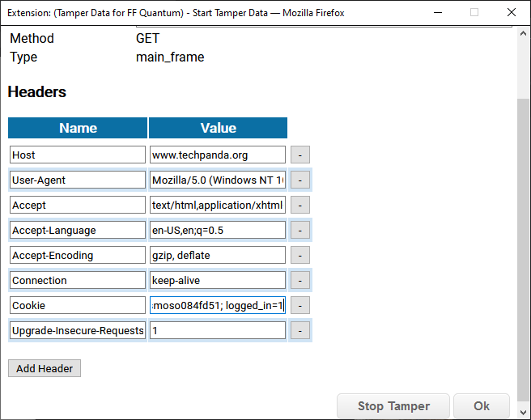

7. In Index.php page Paste the Copied Session id In Cookie and click on OK.

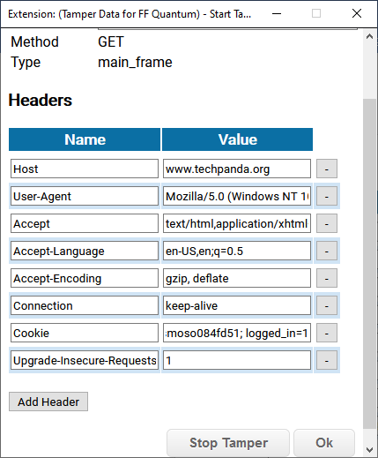

8.In dashboard,php page and again paste the session id into it.

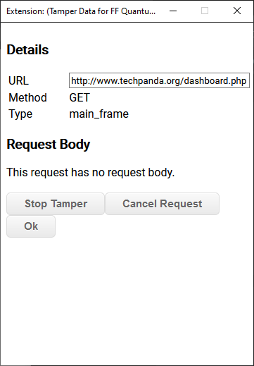

9. Click on Ok → You should see the logged in dashboard directly without logging in.

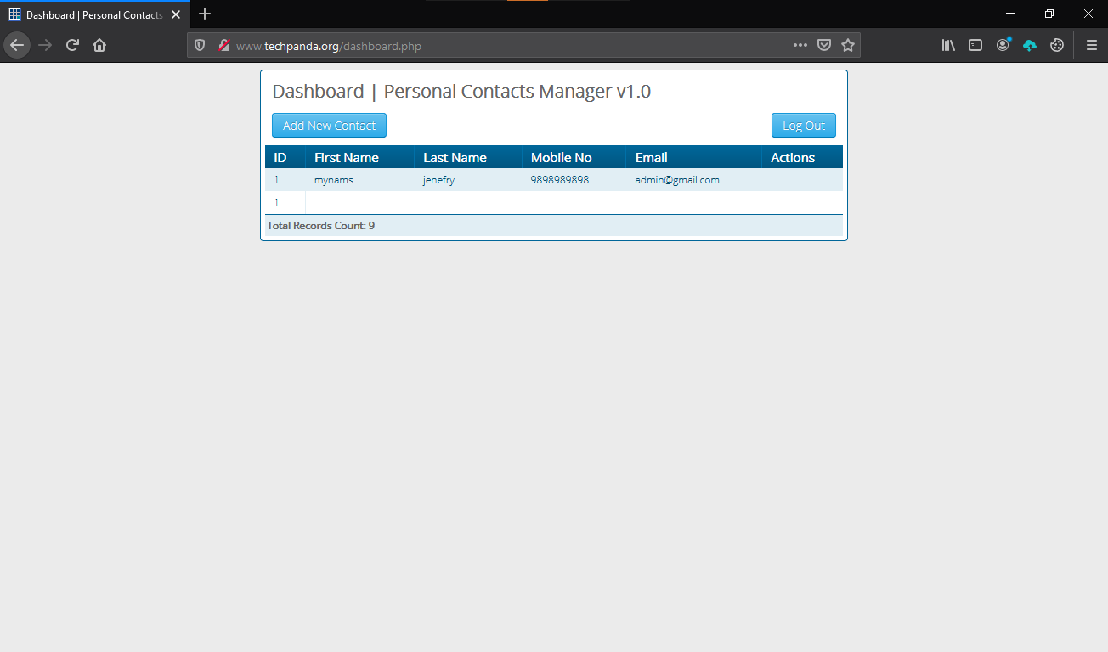

**Date:15/04/2021**

**Practical No: 8**

**Aim:** Open XAMPP server and start MySQL and apache server services.

**Prerequisites:**

* DVWA.zip file.
* XAMPP Server.
* Windows OS.

**Steps**

Step 1: Open XAMPP server and start MySQL and apache server services.

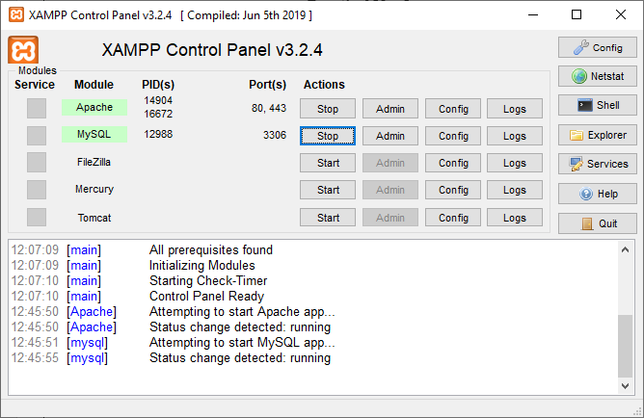

Step 2: In another tab search **localhost/phpmyadmin/**

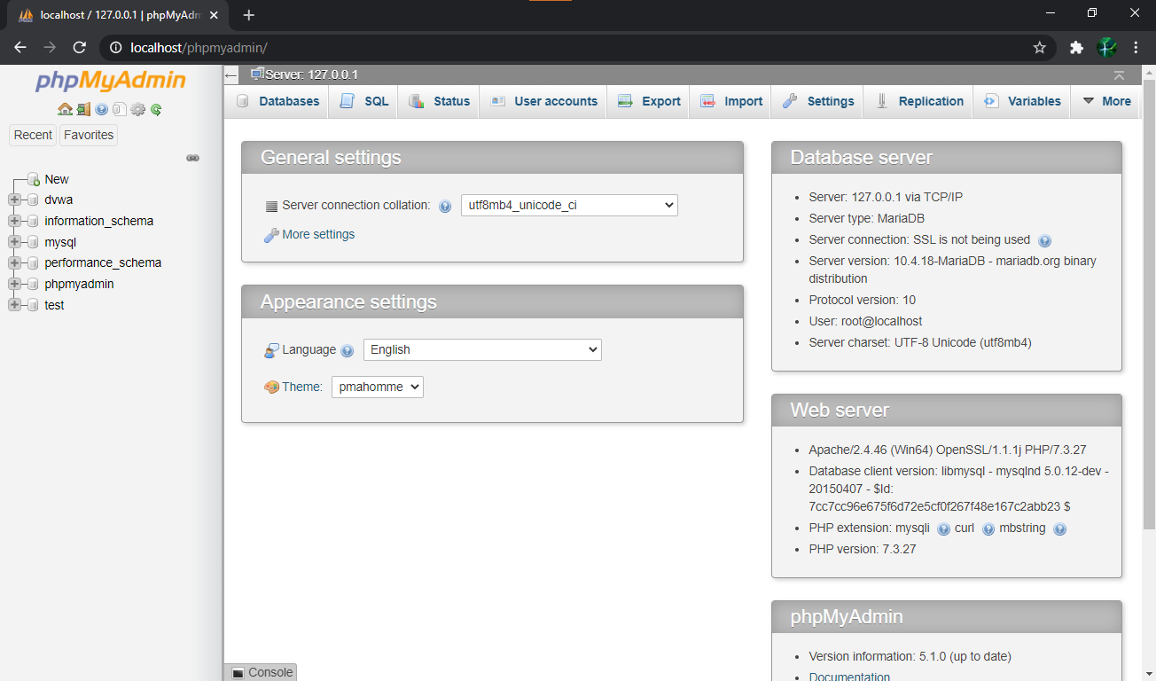

Step 3: Open http://localhost/DVWA-master/login.php page in your web browser

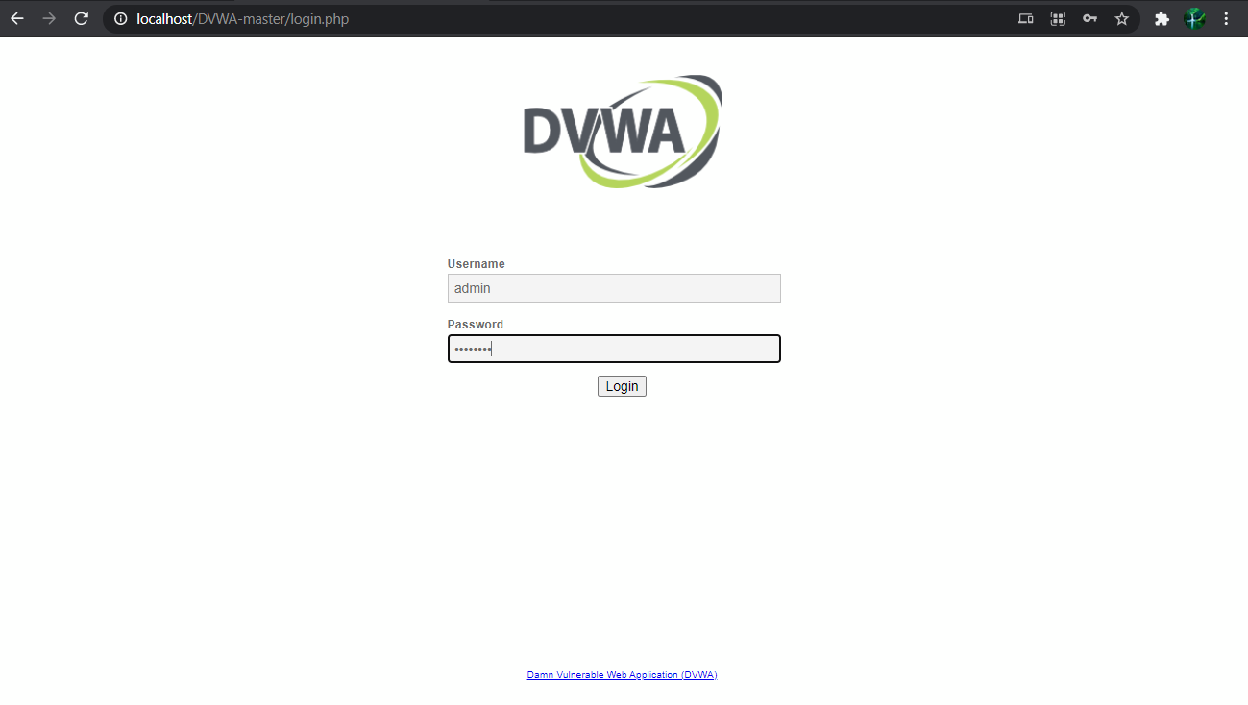

Step 4: Go to DVWA Security and change the security level to low.

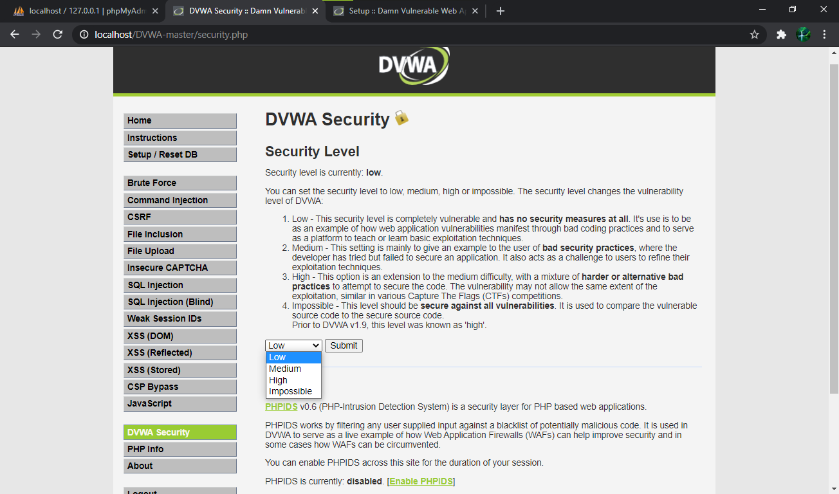

Step 5: The Security level will be lowered to low mode.

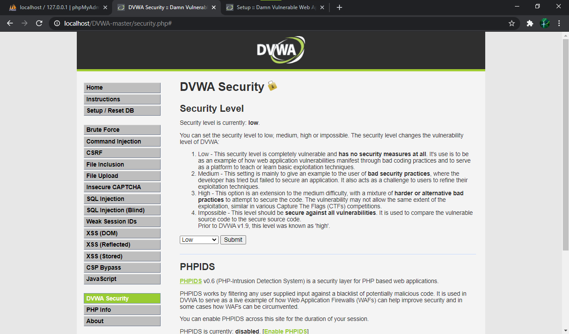

Step 6: Now, go to the “SQL Injection” section of the webpage.

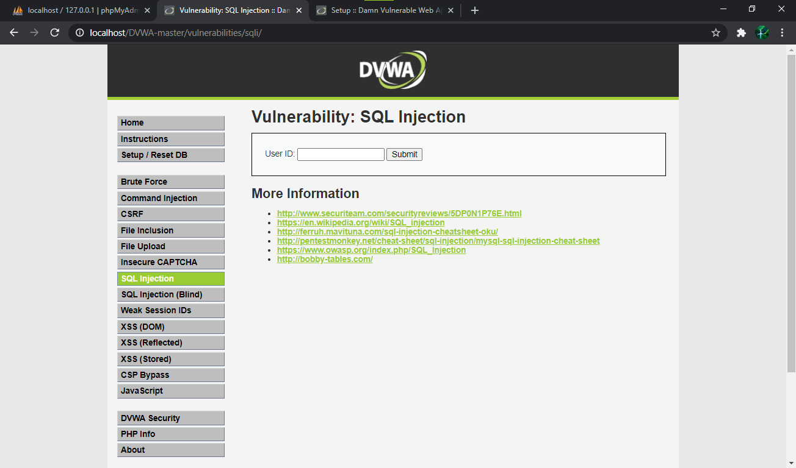

Step 7: Enter User ID as “1” and hit Submit.

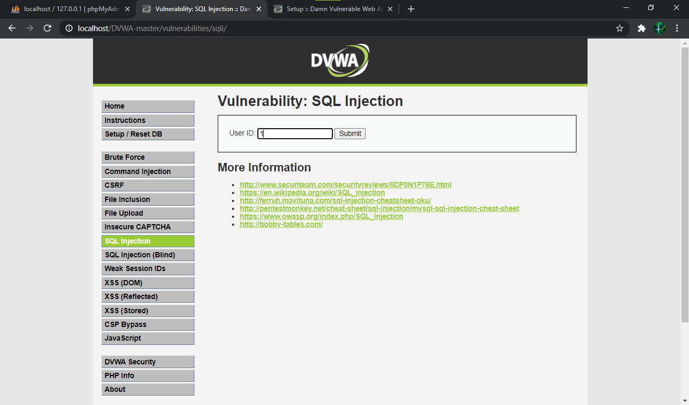

Step 8: It will show you the information stored of 1st user in the database.

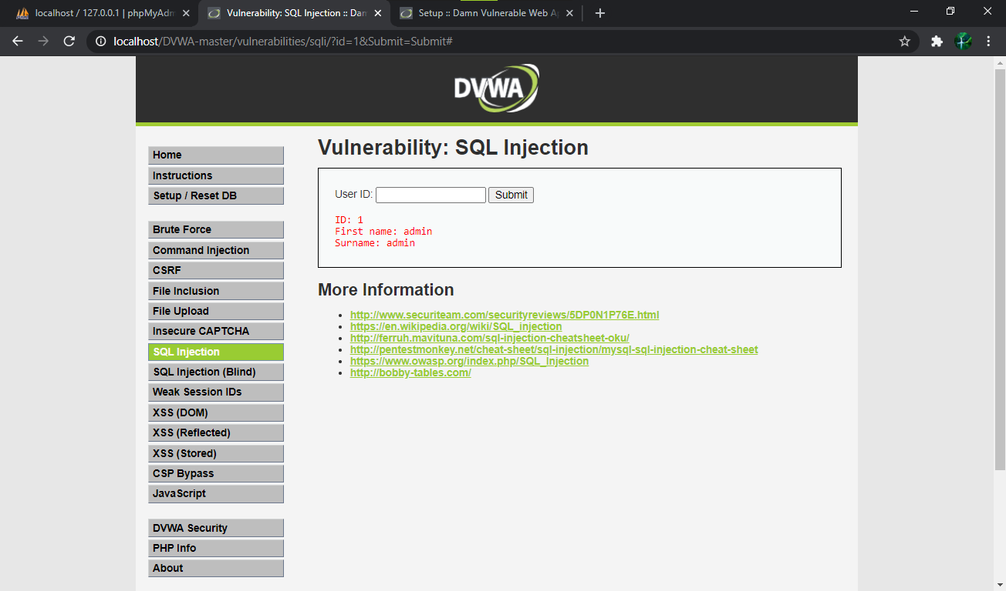

Step 9: You can also get information of 2nd user by entering User ID as “2”.

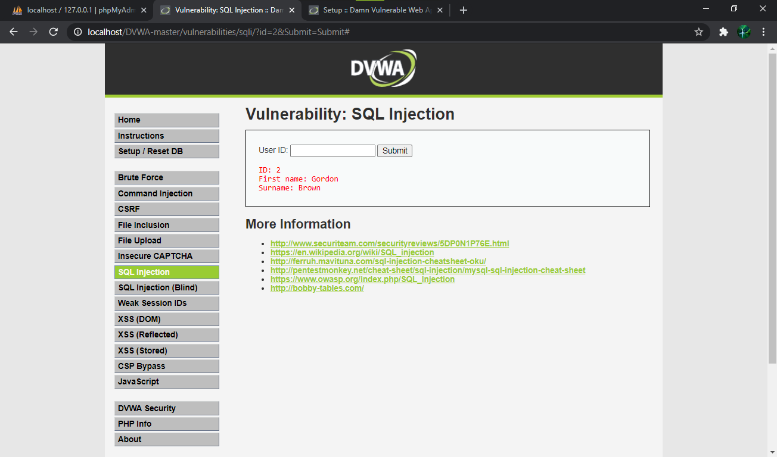

Step 10: To get all the information, type User ID as “1 or ‘=’”.

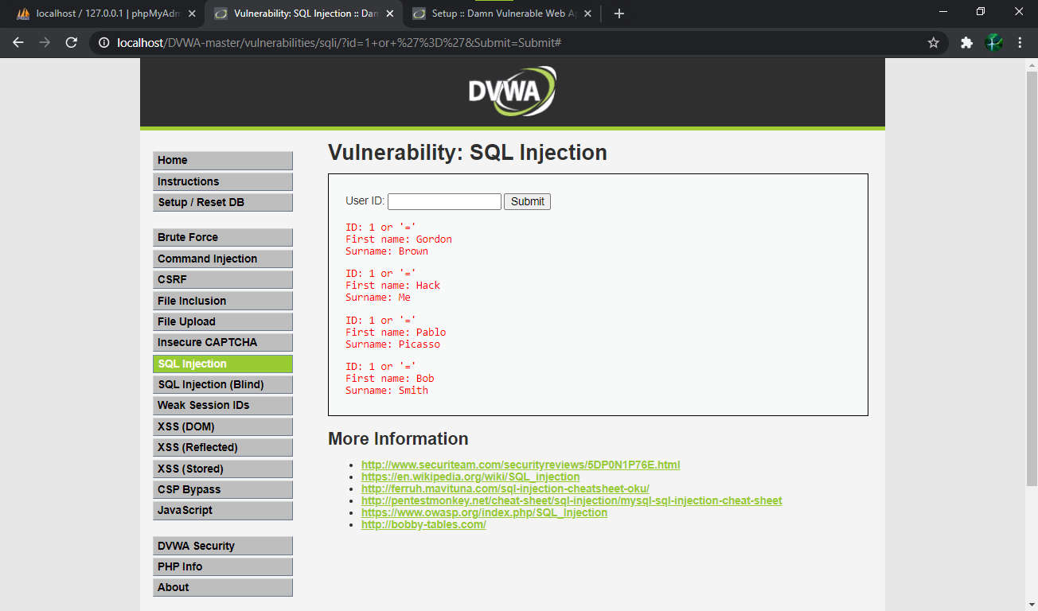

Step 11: To get all the information, type User ID as “a or ‘=’”.

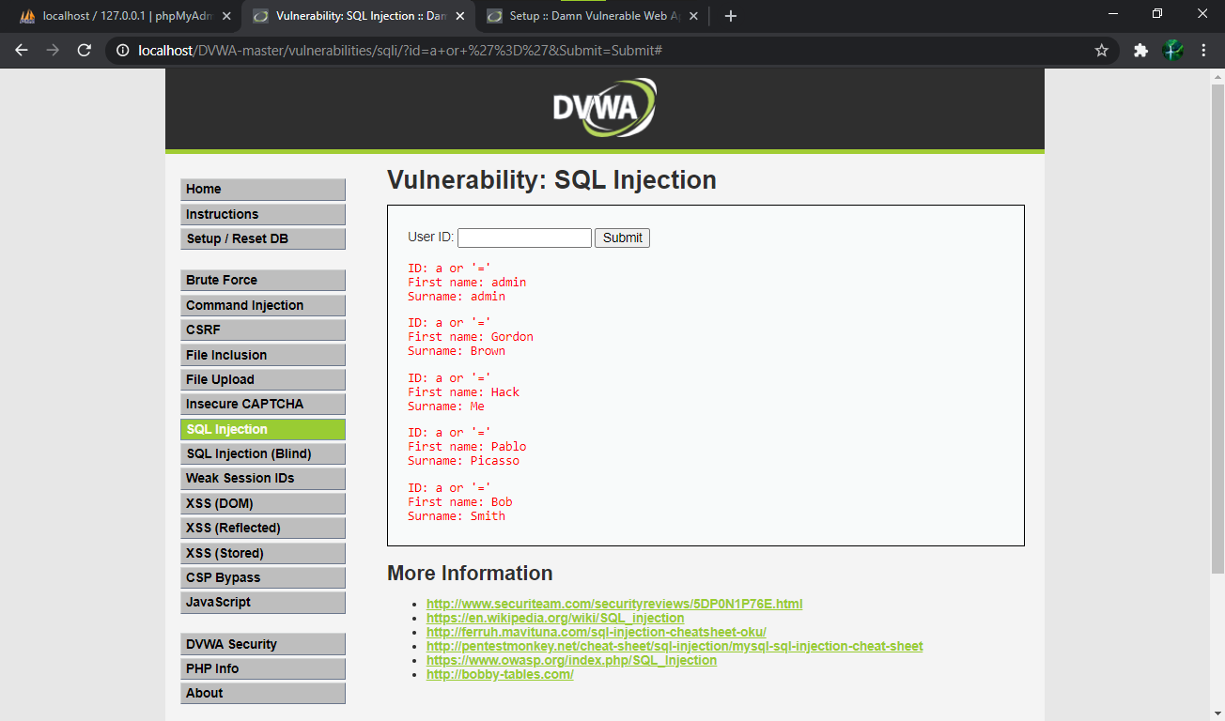

Step 12: Now, go to DVWA Security and change security level to high.

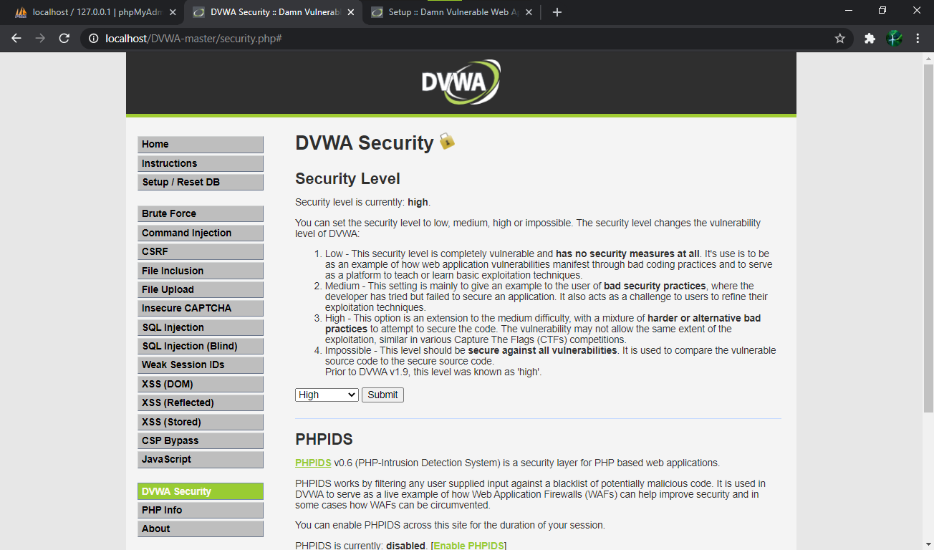

Step 13: Click on “here to change your ID” and enter “a or ‘=’”. Click Submit.

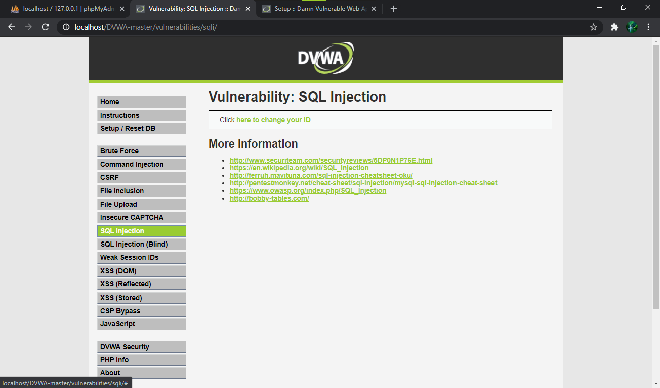

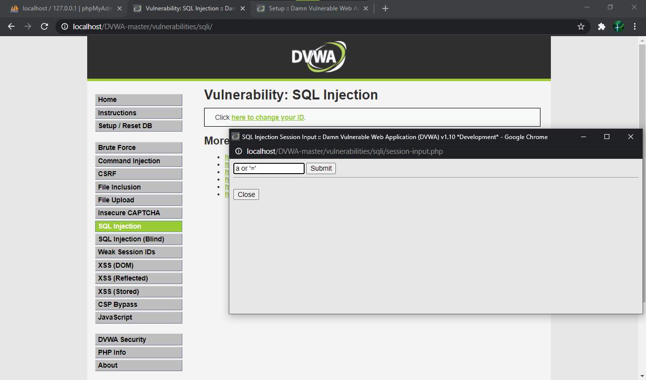

Step 14: Because of the high security mode, this time we can’t get all the information but only one at a time.

